Livestock Evaluation Junior and Middle School CDE

Purpose
The purpose of the Livestock Evaluation Career Development Event is to provide a competitive event for agricultural education students, emphasizing skills in livestock evaluation, selection, and management as taught through the agricultural education curriculum.
The objectives of this event include:
- Understanding and interpreting performance data based on industry standards;
- Selecting and marketing livestock that will provide increased economic returns;
- Communicating industry terminology effectively; and
- Identification of criteria used in grading livestock.

Sponsor
The Livestock Evaluation CDE is sponsored by the North Carolina Cattlemen’s Association and Horace Johnson as a special project of the North Carolina FFA Foundation.

State Event Superintendent
The superintendent for this event is Mr. Jason Davis, State FFA Coordinator, Campus Box 7654 NCSU, Raleigh, NC 27695 Phone: 919-515-4206 Fax: 919-513-3201. Email: jason_davis@ncsu.edu

Eligibility and General Guidelines
This event is open to all FFA chapters and FFA members in grades 6-10 from chapters in good standing. All FFA members in grades 6-10 are eligible to participate in any junior career development event regardless of past participation.

Teams shall consist of three or four members. The fourth lowest team member score is not considered except in the case of a tie. No alternates are allowed in state events. Any alternate found participating in a state event will result in team disqualification.

In order for this event to be recognized as a Middle School FFA Event there must be at least 3 teams participating.

FFA members in good standing may also participate as individuals in this event. A chapter may have up to two members participate as individuals as long as the chapter does not have a team participating in the event. Their scores will only count toward individual recognition, and will not be tallied as a team score. Three members participating in this event from the same chapter constitute a team.
The use or possession of cellular phones, Personal Digital Assistants (PDA’s) or any other mobile electronic communication device is prohibited during any state-level career development event. Any violation of this rule by any team member will result in total team disqualification.

Any member found cheating in any state-level career development event will result in total team disqualification for that event.
Dress Code
Participants are required to follow the North Carolina FFA Career Development Event Dress Code. A ten percent reduction in the total team score will be taken if a participant violates the dress code. Participants are allowed to wear long pants, an appropriate shirt with a collar or an appropriate high school or FFA t-shirt.
Procedures for Administering the Event
Placing Classes – 50 Points per class
- Using Universal Form A, seven classes of four animals will be placed on type.
- Where possible, there will be one class each of breeding cattle, market cattle (includes cattle used for grading and fat cattle used for placing), breeding sheep, market sheep or lambs, market swine, breeding swine, and meat goats. Note: Market goats will be a practice class for the 2007 Livestock Judging Event.
- A maximum of 15 minutes will be allowed
- Contestants will be permitted to view the animals from all angles but will not be permitted to handle the animals (with the exception of market lambs).
- Performance data will be supplied and may be used in selecting animals in breeding classes.
- A perfect score is 50 points per class.

Oral Reasons – 50 Points per class
- Oral reasons will be required for two classes of animals to be designated by the contest official(s).
- One of the two classes will be on breeding animals.
- Production data will be provided on breeding animals and may be used in presenting oral reasons. Students will not be penalized if they choose not to use production data in their reasons.
- Breeding animal oral reasons will rotate between breeding heifers in odd years and breeding swine in even years.
- Contestants will have 15 minutes to place this class.
- A minimum of 15 minutes to prepare reasons
- Two minutes to deliver the oral reasons
- Contestants may use their placing card while giving reasons. No other notes will be permitted.
- A perfect score for reasons is 50 points.

Scoring
7 Placing Classes 50 points/class
2 Oral Reasons 50 points/set

Procedure for Determining the State Event Winner When Scores are Tied
In the event a tie score exists, apply the following methods in sequential order until the tie is broken:

1. Compare the alternate scores. The lowest team member score is the alternate score.
2. If these methods fail to break the tie, co-winners will be declared.

Procedure for Determining the State Event Winner When Scores are Tied for individual participants
Ties in scores between individuals will be broken by comparing the scores for oral reasons for breeding animals. If a tie remains co-winners will be recognized.

State Awards
The following awards will be presented annually at the state FFA convention provided sponsorship is available:
State Winning Team
First place team plaque, team pins for member
Second Place Team
Second place team plaque, team pins for member
Third Place Team
Third place team plaque, team pins for member
Highest Scoring Individual
Belt Buckle

Bibliography
For more information see the National FFA Career Development Events Handbook.

Supplemental Information
A non-refundable event registration fee that includes the meal will be required of all pre-registered teams.

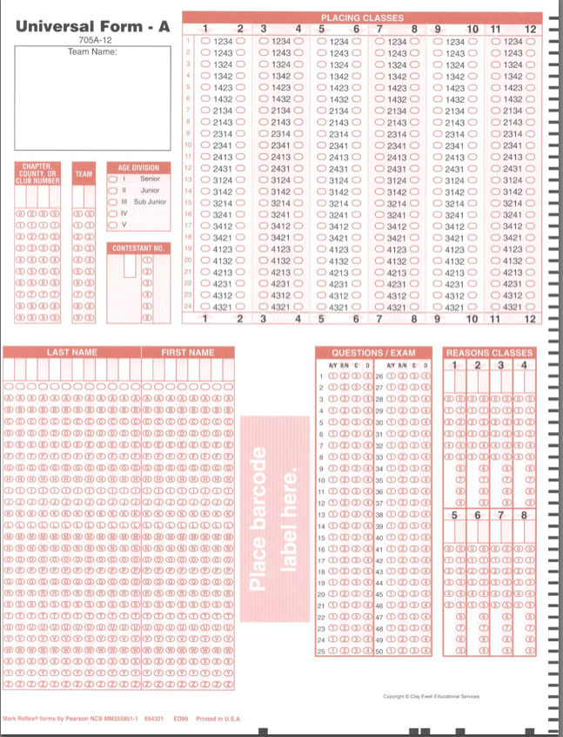

ORAL REASONS SCORECARD

Participant No. ______________________

Participant Name: ___________________

Class No. __________________________

Class Name ________________________

Your Placing _____-_____-_____-_____

- (Posture, clarity in speaking, confidence, convincing)

_______
(Max 12)

- Proper use of Terms
_______
(Max 10)

- Accuracy of Statements (based on what the participant saw)

_______
(Max 10)

- Importance of points covered (reasons for placings, crucial points covered, complete explanation or reasons)

_______
(Max 18)

TOTAL ______________
(Max 50)

