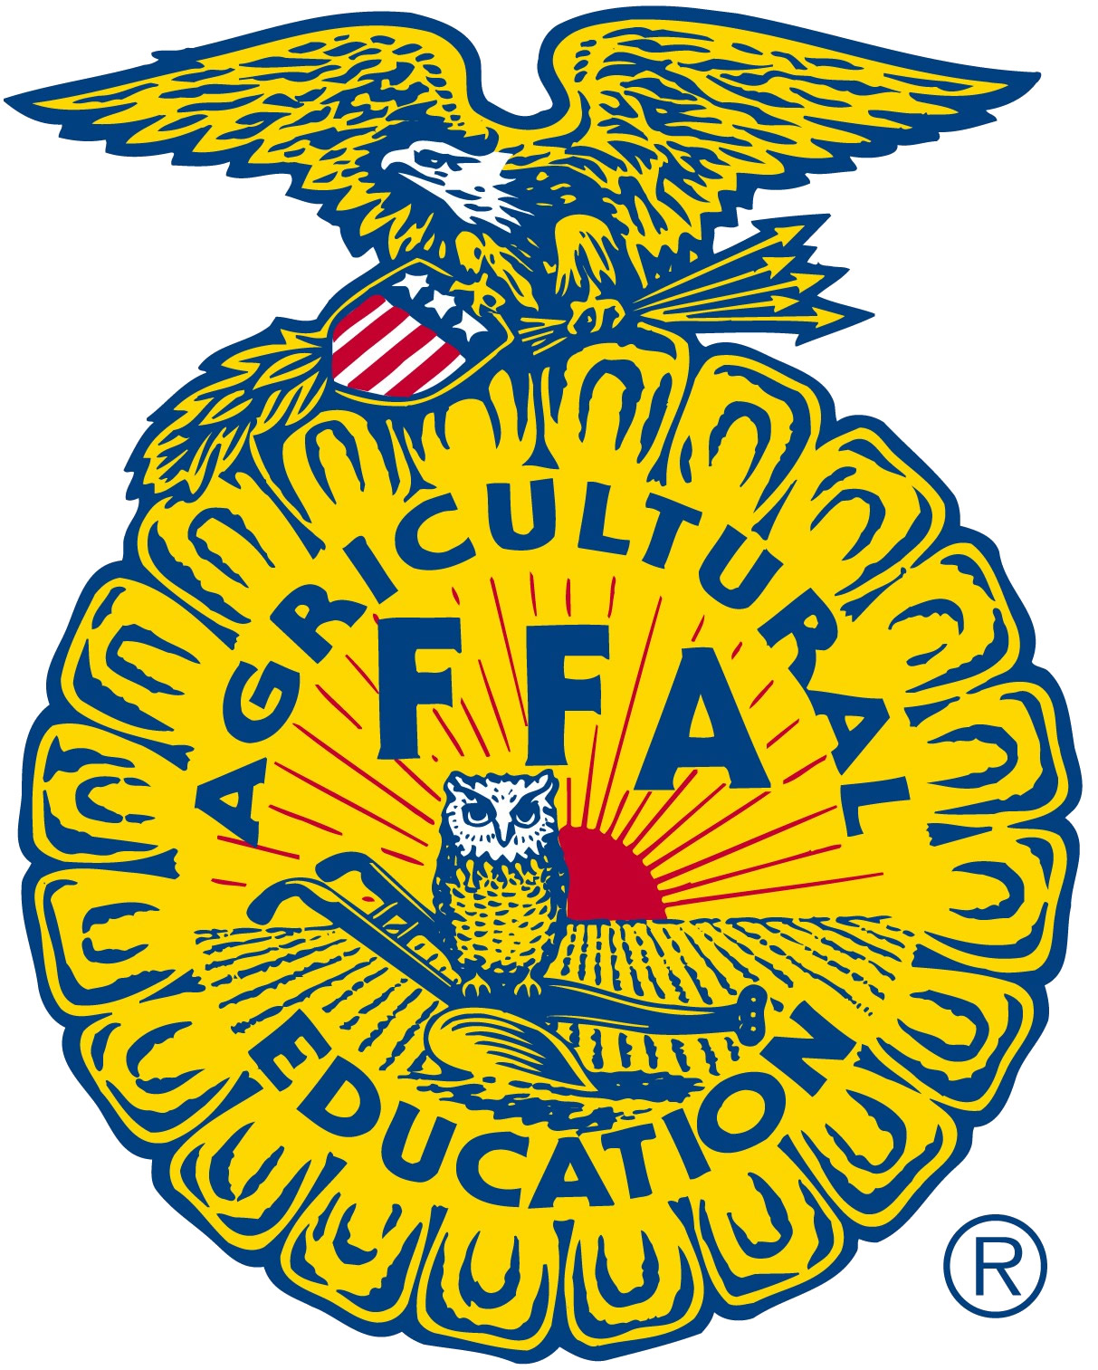
THE FRESH MARKET GRANT

For over thirty years, The Fresh Market has brought the freshest, most delicious quality products from around the corner and around the globe. What started in Greensboro, North Carolina as a dream has grown into a refreshing reality with over 100 stores in over 20 states across the nation. Each one a part of the local community. Each one dedicated to providing the freshest and best local ingredients. Fresh Market now wishes to partner with you, the students in FFA, who are dedicated to becoming the next producers.
Students enrolled in agricultural education and that are FFA members that live within 90 miles of a Fresh Market location may apply for a $500 grant to begin, enhance, or grow their supervised agricultural experience program. Priority will be given to those students whose project produces organic produce. Selected students will be partnered with a Fresh Market location (2014 pilot location is Chapel Hill only) to market and sell their product.

Student Information

Name: ________________________________________________________________________

Address: ______________________________________________________________________

Phone: ___________________________________________ Age: ______________________

FFA Chapter: ___________________________________________________________________

Supervised Agricultural Experience (SAE) Information
Description of your SAE project and requirements:

Tell us how a partnership with The Fresh Market could benefit you and your SAE:

Prepared budget for the $500 grant:

Consent and Release

If student is less than 18 years of age:

I, ___________________________________, authorize my permission for The Fresh
(please print/type parent name)
Market and/or the North Carolina FFA Association to use my child’s photos and videos for any various publications, public affairs releases, and any marketing material.

If student is 18 years of age or older:
I, ___________________________________, authorize my permission for The Fresh
(please print/type student name)
Market and/or the North Carolina FFA Association to use my photos and videos for any various publications, public affairs releases, and any marketing materials.

Required Signatures

Student Signature: _________________________________________ Date: ________________

Parent Signature: __________________________________________ Date: ________________

FFA Advisor Signature: ______________________________________ Date: ________________

