March 8, 2016

Name: Participant #:

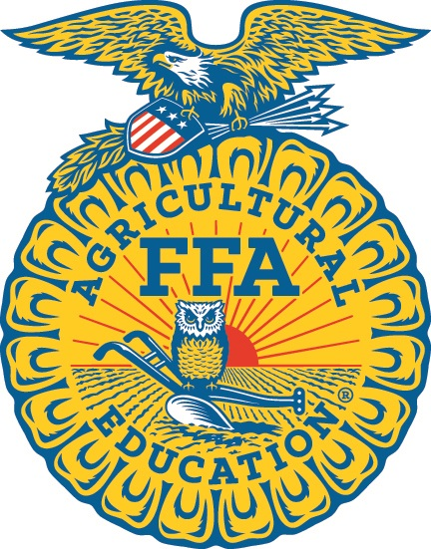

2016

North Carolina FFA

Farm Business Management – SENIOR DIVISION

Career Development Event

Section I: Multiple Choice (100 points)

There are 25 questions on this section of the event. Please check carefully to see that you have five (5) pages including this cover page.

Read each question carefully. Mark your answer for each question on the provided Scantron form. Each question is worth four (4) points. You have 25 minutes to complete this section of the event.
prepared by
Saman J. H. Bandara, PhD.
Program Chair-Agribusiness
Tillman School of Business
University of Mount Olive
634 Henderson St., Mount Olive, North Carolina 28365
919.658.2502

in cooperation with
Department of Agricultural and Extension Education
College of Agriculture and Life Sciences
North Carolina State University

sponsored by
Southern States Cooperative, Inc.
1. Goods that are purchased and brought into the U.S. from a foreign country are known as:
a. tariffs
b. imports
c. exports
d. customs

2. A farm business’s goals are:
a. statements about how you will increase sales of a crop
b. specific plans to plant and harvest a crop
c. specific steps that must be taken to get where you want to be
d. broad statements that show where you want to be after some period of time

3. The law of demand states that, holding other things constant:
a. as price rises, demand will rise
b. as price rises, demand will decline
c. as price falls, quantity demanded rises
d. as price falls, quantity demanded declines

4. If a corn farmer has a yield of 300 bushels per acre, total fixed costs of $175 per acre, and total variable costs of $275 per acre, what is this farmer’s total cost per bushel (i.e. average total cost)?
a. $0.58
b. $0.92
c. $1.50
d. $1.71

5. Which of the following is an opportunity cost of owning and operating farm ground?
a. the lost rent
b. the lost soil
c. labor
d. equipment cost

6. A projected cash flow statement for a business shows future:
a. non-cash needs
b. cash inflow/outflow
c. cash profits
d. cash projects

7. Which type of cost DOES NOT vary with short-run changes in production for a business firm?
a. fixed
b. opportunity
c. marginal
d. labor

8. A business firm owner and risk taker is often called:
a. a socialist
b. a gambler
c. an entrepreneur
d. a corporation

9. If a marketer is said to be ‘bullish,’ they
a. are wanting to sell
b. expect prices to increase
c. expect prices to decrease
d. are greedy

10. Farmer Smith has more current assets than current liabilities. Her current ratio is
a. negative
b. zero
c. between 0 and 1
d. greater than 1

11. Which of the following is most likely to increase the demand for chicken (i.e. shift the demand curve for chicken to the right)?
a. increase in the supply of chicken
b. increase in the price of a substitute product, such as beef
c. decrease in consumers’ incomes so they go out to eat less often
d. increase in the cost of livestock feed used to produce chicken

12. The time value of money concept says a dollar to be received in the future is:
a. worth less than a dollar to be received today
b. worth more than a dollar to be received today
c. worth the same as a dollar to be received today
d. dependent on the value of one’s time (i.e. wage rate)

13. After fertilizing and planting, the costs of seed and fertilizer would normally be
considered:
a. a variable cost
b. a depreciable expense
c. a sunk cost
d. an opportunity cost

14. Niche marketing generally means the sale of:
a. niches
b. a specialized product to specific buyers
c. a product during a very limited time frame
d. a general product that is sold similarly by a large number of other sellers

15. Basis in a futures market is the difference between:
a. a cash price and a non cash price
b. a cash price today and a cash price in the future
c. two different futures prices for the same commodity
d. a futures contract price and a cash price

16. The specific price at which a put option buyer has obtained the right to sell is called:
a. the strike price
b. the premium
c. the basis
d. the price floor

17. The right, but not the obligation, to sell a futures contract at a specified price is known as:
a. a call option
b. a short futures position
c. a put option
d. a long futures position

18. A breakeven price is one that covers:
a. fixed costs
b. future costs
c. variable costs
d. total cost

19. A farmer is considering the purchase of a used combine to harvest corn and soybeans. The machine will have fixed costs of $18,500 per year and variable costs of $30 per acre. The local custom harvest rate (hiring someone else to harvest) is $50 per acre. How many acres per year must be harvested to justify purchasing the used combine?
a. 370
b. 615
c. 925
d. 1850

20. The general economic term used to describe where and when buyers and sellers interact regarding a specific product is called:
a. a franchise
b. a contract
c. a market
d. an arbitrage

21. Deposits at U.S. commercial banks are insured by
a. the U.S. Federal Reserve
b. the New York Stock Exchange
c. the Federal Deposit Insurance Corporation
d. the Chicago Mercantile Exchange
22. On an agricultural producer’s balance sheet, which of following contains only current liabilities?
a. principal due within a year on five year loans, cleaned home grown wheat seed
b. accrued interest, calves that died within the last year
c. a broken water pump, amount owed to the implement dealer for machinery parts
d. amount owed to the elevator for feed, principal due within a year on loans with a
term of seven years

23. On an agricultural producer’s balance sheet, which of following contains only current assets?
a. tractor, cow/calf pairs, $500 in cash
b. barley seed, fertilizer, pole barn
c. feeder calves, corn silage, balance in checking account
d. water well, wheat in a bin, herd bull

24. Which of the following DOES NOT directly affect a rancher’s net return per cow?
a. protein supplement falling costs
b. market price for the calves at weaning
c. pounds weaned per exposed cow
d. interest paid on equipment loans

25. Cash flow statements are used to analyze:
a. the equity position of a farm business
b. solvency
c. profitability
d. none of the above

End of the multiple choice section of the 2016 NC FBM CDE

