March 4, 2015

Name: Participant #:
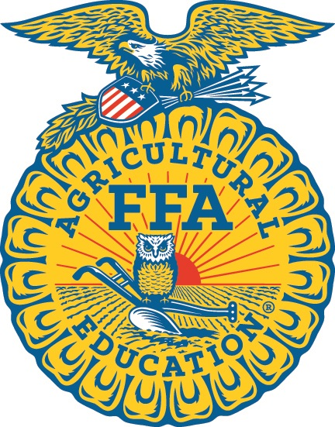

2015

North Carolina FFA

Farm Business Management- JUNIOR DIVISION

Career Development Event

Section I: Multiple Choice (100 points)

There are 20 questions on this section of the event. Please check carefully to see that you have four (4) pages including this cover page.

Read each question carefully. Circle the letter for the one best answer. Each question is worth five (5) points. You have 30 minutes to complete this section of the event.

prepared by
Saman J. H. Bandara, PhD.
Program Chair-Agribusiness
Tillman School of Business
University of Mount Olive
634 Henderson St., Mount Olive, North Carolina 28365
919.658.2502

in cooperation with
Department of Agricultural and Extension Education
College of Agriculture and Life Sciences
North Carolina State University

sponsored by
Southern States Cooperative, Inc.

1. Almost _____________of all U.S. farms are owned by individuals, family partnerships, and
family corporations.
a) 97%
b) 1%
c) 94%
d) 22%

2. American farmers and ranchers receive only ________ out of every dollar spent on food that
is eaten at home and away from home.
a) 19 cents
b) 31 cents
c) 81 cents
d) 69 cents

3. Agribusiness in the United States:
a) is the largest industry in the United States.
b) accounts for about 20% of the national total economic output.
c) is the country’s largest single employer, providing more than one out of every
five jobs.
d) all of the above

4. American farmers could be:
a) business people.
b) environmentalists.
c) animal caretakers.
d) all of the above

5. The value of a resource in its next best use is called:
a) fixed cost.
b) opportunity cost.
c) sunk cost.
d) variable cost.

6. The four factors of production are:
a) cash inflows, assets, rent payments received, and profits.
b) seed, feed, fertilizer, and chemicals.
c) land, labor, capital, and management.
d) records, budgets, financial statements, and income tax returns.

7. The real interest rate is:
a) the observed interest rate plus the rate of inflation.
b) the nominal interest rate minus the observed interest rate.
c) the observed interest rate minus the nominal interest rate.
d) the observed interest rate minus the rate of inflation.

8. A capital investment that an investor is considering has an internal rate of return of 16%, the
investor’s discount rate or cost of capital is 12%. The investment:
a) should be accepted.
b) is not profitable.
c) has a negative net present value.
d) none of the above.
9. A statement of projected costs and returns for an entire farm plan is called the:
a) cash flow projection.
b) whole farm budget.
c) enterprise budget.
d) partial budget.

10. The percent change in quantity demanded divided by percent change in price is:
a) income elasticity of demand
b) income elasticity of supply
c) price elasticity of demand
d) price elasticity of supply
11. Which of the following would not appear on a cash flow statement?
a) Interest paid on a loan for a tractor
b) Principal paid on a loan for a tractor
c) Depreciation expense on a tractor
d) Rental payment received from the neighbor who used the tractor

12. The law of demand states that, holding other things constant, as price rises:
a) supply will rise.
b) demand will remain constant.
c) quantity demanded rises.
d) quantity demanded declines.

13. A situation in which a single company or group owns all or nearly all of the market for a
given type of product or service is called:
a) pure competition.
b) competitive.
c) monopolistic competition.
d) a monopoly.

14. The purpose of income tax management is to:
a) simplify a farm’s revenue and expenses.
b) hide as much farm income as possible.
c) minimize what your send to the Internal Revenue Service.
d) maximize after tax profits.

15. The ability of a business to meet cash flow obligations as they come due is called:
a) liquidity
b) solvency
c) depreciation
d) liability

16. The method used to figure out how much future payments are worth today is
known as:
a) compounding.
b) discounting.
c) amortization.
d) depreciation.

17. The partnership is:
a) the oldest and simplest form of business organization.
b) the most popular form of organization.
c) owned and controlled by one person.
d) two or more people operate as co-owners.

18. The accrual income statement is used to analyze:
a) the equity position of a farm business.
b) solvency.
c) profitability.
d) all of the above

19. By adding a feed mill to a dairy cattle operation, a producer becomes more:
a) specialized.
b) diversified.
c) integrated.
d) motivated.

20. Fundamental market analysis in commodity hedging and/or speculating is most useful in
determining:
a) entry levels.
b) exit levels.
c) market direction.
d) market momentum.
e) all of the above.

End of the multiple choice section of the 2015 NC FBM Junior CDE

