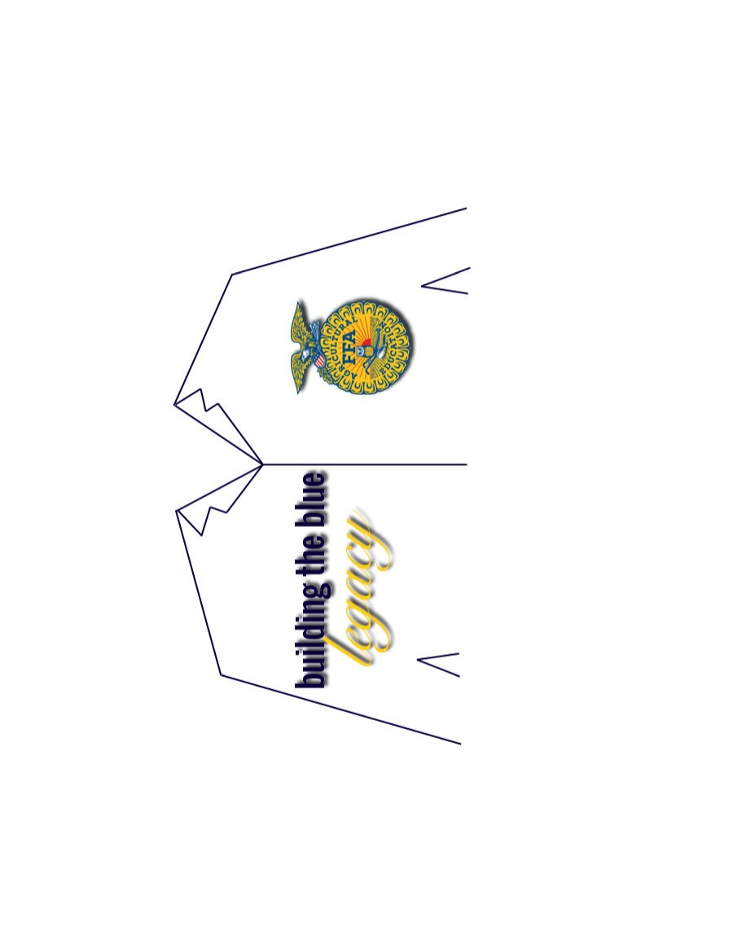

**$75** - FFA Jacket at large



*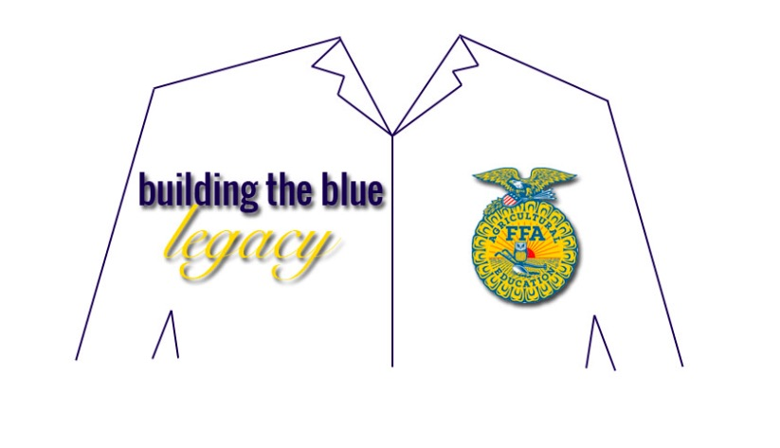***$525** - FFA 10 Jackets set at large



$_______________ - FFA Jacket at large



(amount)

*Recipients will be selected by the NC FFA*

Donations due by **May 3rd** to the NC FFA Foundation

NCSU Box 7654

Raleigh, NC 27695-7654

**Make checks payable to NC FFA Foundation**

**Contribution is 100% Tax Deductible**