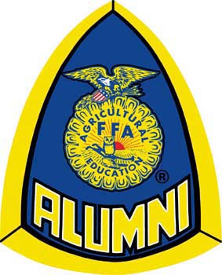
North Carolina FFA Alumni Association
Did you remember to invite…?

North Carolina FFA Alumni Affiliates are serving FFA chapters, communities, the North Carolina FFA Association and the National FFA Organization in unique and amazing ways every year. They hold dinners, community breakfasts, fundraisers, networking events, and many more activities that promote community, agriculture, education, youth and the FFA. Developing an invitation list is an important part of any event planning.
FFA Alumni Affiliates realize the importance of including and inviting community, civic, and school personnel members as well as those who support FFA. Below is a list of suggested groups to invite when planning FFA chapter or FFA Alumni events. Don’t forget to recognize those who take time to attend!
Invite List | Student Contact | Confirmed Contact
School District Superintendent
CTE Director
Principal
Assistant Principal(s)
Other School Administrators
Elected Officials
Members of Board of Education
Community Leaders
Similar Civic Organizations
Parents
Engaged School Teachers & Faculty
Donors/Sponsors
Stakeholders
State Agricultural Education/FFA Staff
Former Members

- The Student Contact section can be used to place a member/officer in charge of contacting individuals on the invite list. The Confirmed Contact section can be used to place a check in once contact has been made.

