March 4, 2015

Name: ________________________________ Participant #: ______________

2015

North Carolina FFA Farm Business Management Senior
Career Development Event

Section II: Problem Solving (200 points)

Read each problem carefully. Check to see that you have 20 pages including the cover page.
You have 100 minutes to complete this section of the Career Development Event.

prepared by
Saman J. H. Bandara, PhD.
Program Chair-Agribusiness
Tillman School of Business
University of Mount Olive
634 Henderson St., Mount Olive, NC 28365
919.658.2502

in cooperation with
Department of Agricultural and Extension Education
College of Agriculture and Life Sciences
North Carolina State University

sponsored by
Southern States Cooperative, Inc.

Contents
Contents 2
Table 1. Statements of Net Worth 4
Table 2. Income Statements 5
Table 3. Future Value (FV) of $1 Investment 6
Table 4. Present Value (PV) of $1 Lump Sum 7
Table 5. Present Value (PV) of $1 Annuity 8
Part 1 – Analysis of Balance Sheets 10
Part 2 – Analysis of Income Statements 12
Part 3 – Analysis of Cash Flow 14
Part 4 – Time Value of Money 15
Part 5A – Partial Budgeting 17
Part 5B – Agricultural Futures and Options 18
Part 6 – Cost and Return Analysis 19

2015 NC FFA Farm Business Management

Resource Information

Table 1. Statements of Net Worth
Resource Information for the Smith’s Farm Business, as of 12/31/2012 and 12/31/2013

 | 12/31/12 | 12/31/13
Assets
Current assets
Cash in farm account | 9,341 | 3,690
Farm accounts receivable | 0 | 0
Stored crops | 1,440 | 4,200
Growing crops | 234,000 | 198,000
Other current assets | 0 | 0
Total current assets | 244,781 | 205,890
Non-current assets
Machinery and buildings | 84,960 | 79,164
Land | 625,500 | 687,500
Total Non-Current Assets | 710,460 | 766,664
Total farm assets | 955,241 | 972,554
Liabilities
Current liabilities
Short term notes payable | 22,796 | 16,618
Accounts payable | 11,970 | 14,533
Portion of machinery and land debt due | 38,118 | 34,307
Accrued liabilities (taxes, rent) | 0 | 2,200
Accrued interest | 0 | 0
Total current liabilities | 72,884 | 67,658
Non-current liabilities
Non- current liabilities due after one year | 93,760 | 85,515
Land payment due after one year | 290,000 | 245,000
Total non-current liabilities | 383,760 | 330,515
Total Farm Liabilities | 456,644 | 398,173
Net Worth (Equity) | 498,597 | 574,381

Table 2. Income Statements
Resource Information for the Smith’s Farm Business

 | 2012 | 2013
Revenue
Wheat | 473,000 | 493,900
Tomatoes | 85,800 | 60,600
Tobacco | 168,300 | 193,200
Strawberries | 96,000 | 142,100
Farm service agency payments | 0 | 0
Total revenue | $823,100 | $889,800
Expenses
Cash operating expenses
Chemicals | 221,000 | 232,056
Fertilizer & Lime | 48,295 | 51,571
Freight/Tucking | 21,268 | 21,435
Gas, fuel, oil | 27,829 | 29,657
Insurance | 83,521 | 94,520
Crop insurance | 22,244 | 26,432
Labor hired | 128,760 | 150,784
Machine hire | 6,789 | 7,113
Repairs-machinery | 20,775 | 23,145
Repairs -building | 17,335 | 18,236
Seeds/plants | 64,735 | 44,536
Storage | 5,200 | 5,680
Supplies | 15,517 | 17,703
Taxes | 23,705 | 31,360
Utilities – farm share | 7,867 | 10,411
Miscellaneous farm expenses | 9,678 | 8,248
Total Cash Operating Expenses | $724,518 | $772,887
Inventory adjustments
Accounts payable | 16,121 | 19,662
Change in accrued taxes | 3,300 | 2,940
Other accrued expenses | 2,070 | 2,220
Depreciation | 14,984 | 12,580
Total operating expenses | $760,993 | $810,289
Cash interest paid | 15,360 | 14,268
Change in interest payable | 0 | 0
Total interest expense | $15,360 | $14,268
Total Expenses | $776,353 | $824,557
Net Farm Income From Operations | $46,747 | $65,243

Table 3. Future Value (FV) of $1 Investment

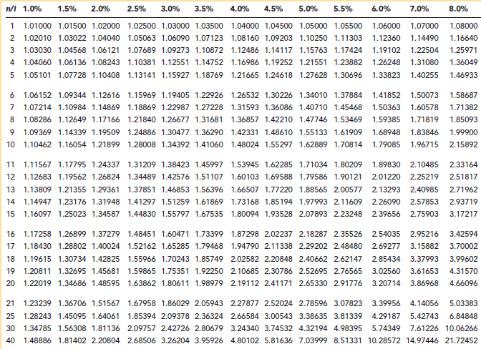

Table 4. Present Value (PV) of $1 Lump Sum

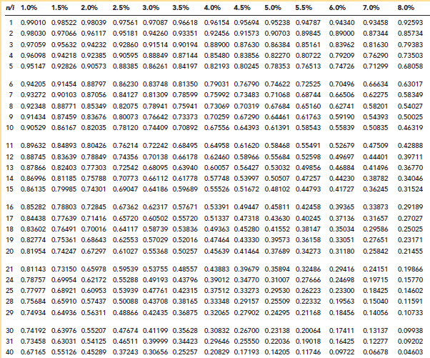

Table 5. Present Value (PV) of $1 Annuity

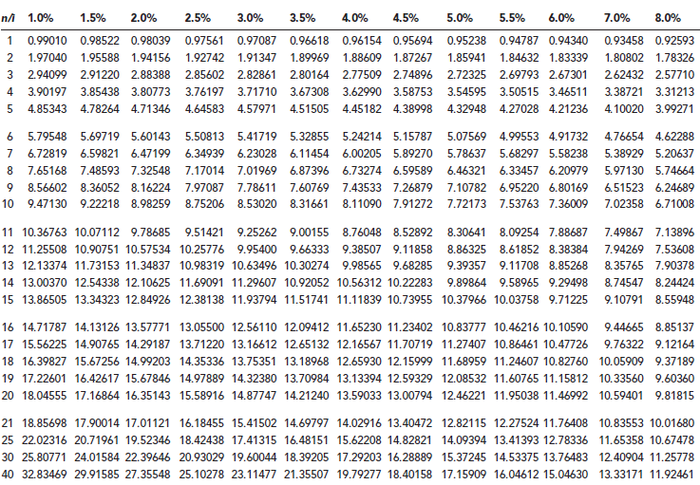

2015 NC FFA Farm Business Management

Problem Solving Section

Part 1 – Analysis of Balance Sheets
48 points

Questions 1 through 12 refer to Smith Farm Business Table 1. Statements of Net Worth on page 4.
Round ratios to two decimals. Each question is worth 4 points.

- What was Smith’s Farm Business Working Capital on December 31, 2012?

$171,897 (working capital = current assets-current liabilities)

- What was Smith’s Farm Business Current Ratio on December 31, 2012?

3.36 (current ratio = current assets/current liabilities)

- What was the Debt-to-Asset ratio of Smith’s Farm Business on December 31, 2013?

0.41 (debt/asset ratio = total liabilities/total assets)

- What was the Equity-to-Asset ratio of Smith’s Farm Business on December 31, 2013?

0.59 (equity/asset ratio = equity/total assets)

- What was the Debt-to-Equity ratio of Smith’s Farm Business on December 31, 2013?

0.69 (debt/equity ratio = total liabilities/total equity)

- What was the debt structure ratio of Smith’s Farm Business on December 31, 2013?

0.17 (debt structure ratio = current liabilities/total liabilities)

- Name three ratios that can be used to analyze solvency of Smith’s Farm Business?

Debt-to-Asset ratio

Equity-to-Asset ratio

Debt-to-Equity ratio

- Name the two ratios that can be used to analyze liquidity of Smith’s Farm Business?

Current ratio

Working capital

- Consider the change in liquidity of Smith’s Farm Business between December 31, 2012 and December 31, 2013. Based on the balance sheet information, was the farm business:

- More liquid on December 31, 2012**
- More solvent on December 31, 2013
- Less liquid on December 31, 2012
- None of the above

- What percent of Smith’s Farm Business assets were financed by equity on December 31, 2012?

52.20% (equity/total assets x 100)

- True or False: If the Debt-to-Equity ratio increases, the Debt-to-Assets ratio also increases?

True

- True or False: A business with a higher working capital will have a higher current ratio?

True

Part 2 – Analysis of Income Statements
30 points

Questions 1 through 6 refer to Smith’s Farm Business Table 1. Statements of Net Worth on page 4 and Table 2. Income Statements on page 5. Round your answers to two decimals. Each question is worth 5 points.

Important Notes:
- Opportunity Cost of Unpaid Labor is $30,000
- Opportunity Cost of Management is $5,000
- Opportunity Cost of All Capital is 5%

- What is the rate of return on assets in 2013?

4.62 %

{(65243+14268-30000-5000)/[(955241+972554)/2]}*100 = 4.62%
([NFI + Interest – Op. Cost of Unpaid Labor- Opp. Cost of Mgt) / [(Average Value of Asset])*100

- What is the rate of return on equity in 2013?

5.64 %

{(65243-30000-5000)/[(498467+574381)/2]}*100 = 5.64%
([NFI – Opp. Cost of Unpaid Labor- Opp. Cost of Mgt] / [(Average Value of Equity])*100

- What is the asset turnover ratio in 2013?

92.31 % or 0.9231 or 0.92

889800/[(955241+972554)/2]}*100 = 92.31% or 0.9231
([Gross Revenue) / [(Average Value of Assets])*100

- What is the return to labor and management in 2013?

$ 31,316.13

65243+14268-48194.87 = 31316.13
(NFI + Interest – Opp. Cost of All Capital) [All capital = Average Value of Assets]

- What is the net farm income from operations ratio in 2013?

7.33 % or 0.073 or 0.07

65243/889800 = 0.073 or 7.33
(NFI / Gross revenue)

- What is the operating profit margin ration for 2012?

3.29 % or 0.0329 or 0.03

(46747 + 15360 -30000-5000)/823100 = 3.29% or 0.0329
([NFI + Interest - Opp. Cost of Unpaid Labor- Opp. Cost of Mgt] / [(Total Revenue])*100

Part 3 – Analysis of Cash Flow
36 points

Mr. Smith likes to have his cash situation on annual basis. In this section, complete the information about the Smith Farm Business cash flow based on the information given below.
Round to the nearest dollar. Each question is worth 4 points

Important note: The Smiths must maintain a minimum cash balance of $2,000.

Year | 2012 | 2013
Beginning cash balance | 4,000 | 2000
Cash inflow:
Farm product sales | 8,000 | 48,000
Capital sales | 0 | 20,000
Miscellaneous cash income | 0 | 2,000
Total cash inflow | *12,000 | 72,000
Cash outflow:
Farm operating expenses | 14,000 | 7,200
Capital purchases | 40,000 | 0
Miscellaneous expenses | 2,000 | 800
Total cash outflow | * 56,000 | *8,000
Cash balance | *- 44,000 | *64,000
Borrowed funds needed | * 46,000 | 0
Loan repayments (principal + interest) | 0 | 46,800
Ending cash balance | 2,000 | 17,200
Debt outstanding | 46,000 | 0

1. What is the total cash inflows in 2012? 12,000
2. What is the total cash outflow in 2012? 56,000
3. Which year has the largest cash inflow? 2013
4. Which year has the smallest cash outflow? 2013
5. What was the cash balance in 2013? 64,000
(total cash inflow-total cash outflow)
6. How much was borrowed in 2012? 46,000 (ending cash balance is 2000, cash balance is -44000, so it needs 46000 to borrow to maintain ending balance of 2000)
7. How much was paid as the interest for borrowed funds? 800
8. How much does it need to borrow in 2013 to maintain
the listed ending balance? 0
9. What is the ending cash balance in 2013? 17,200

Part 4 – Time Value of Money
30 points
PV = FV/ (1 +r)^{n}
- PV = Present
- FV = Future Value
- r = interest or discount rate
- n = number of years

Use Tables 3-5 (on pages 6-8) or the formula in the box above to calculate the value for questions 1 – 4. Write your answer(s) in the blank(s) provided for each question. Show your calculations (ask the proctor for another sheet if necessary). Round answers to two decimals. Each question is worth 5 points except question 3 which is worth 15 points).

- If farmland is currently worth $2,850 per acre and is expected to increase in value at a rate of 5% annually, what will the land be worth in 8 years?

$4,210.76 or $4,210.74

$4210.76 or $ 4210.74
[ from Table 3: $2,850 x 1.47746 = $4210.76 or by formula: FV = PV * (1 + r)^{n}
= ($2850) (1.05)⁸ = $4210.74]

- If farmland is currently worth $2,850 per acre and is expected to increase in value at a rate of 6% annually, what will the land be worth in 12 years?

$5,734.77 or $5,34.76

$ 5734.77 or $5734.76
[From Table 3: $2,850 x 2.01220 = $5734.77 or by formula: FV = PV * (1 + r)^{n}
= ($2850) (1.06)¹² = $5734.76]

- If you require a 4.5% rate of return, how much could you afford to pay for an acre of land that has expected annual net cash revenues of $65 per acre for 12 years and an expected selling price of $2,500 per acre in 12 years? [15 points]

+ present value of net cash revenues $592.71
+ present value of expected selling price $1,474.15
= amount you could afford to pay $2,066.86

[from Table 5: present value of net cash revenues: $65 * 9.11858 = $ 592.71
from Table 4: present value of expected selling price: $2500 * 0.58966 = $1,474.15
$592.71+ $1,474.15 = $2.066.86 or by the formula:
PV = FV / (1 + r)^{n} = 65/ (1.045) ¹ + 65/ (1.045)² + 65/ (1.045) ³ +65/ (1.045) ⁴ +65/(1.045) ⁵ + 65/ (1.045)⁶ + 65/ (1.045)⁷ + 65/ (1.045)⁸ + 65/(1.045) ⁹ + 65/ (1.045) ¹⁰ + 65/ (1.045) ¹¹ + 65/ (1.045) ¹²+ 2500/ (1.045) ¹² = 62.20 + 59.52 +56.95 + 54.50 + 52.15 + 49.91 + 47.76 + 45.70 + 43.73 + 41.85 + 40.05+38.32+1474.15 = 2066.86]

- Mr. Smith wishes to have $80,000 ten years from now as a college fund for his son. How much money would have to be invested today at 4% compound interest?

$54,044.80 or $54,045.29 or $54,045.13

$ 54044.80 or 54045.28 or 54045.13
[from Table 4: $80,000 * 0.67556 = $54,044.80 OR Table 3 on page 8: $80,000 / 1.48024 = 54045.28 or by the formula: PV = FV / (1 + r)^{n} = 80000 / (1.04)10 = 54045.13]

Part 5A – Partial Budgeting
16 points

Use the Partial Budget below to determine if the Smith Farm Business should add 100 beef cows on 200 acres rented land and convert 20 acres of cropland to feed production. (Each question is worth 4 points).

Partial Budget
Alternative: Add 100 beef cows on 200 acres rented land and convert 20 acres of cropland to feed production
Additional Costs: |  | Additional Revenue:
Fixed costs |  | 22 cull cows | 7,700
Interest on cow/bulls | 3,750 | 33 heifer calves | 16,165
Bull depreciation | 200 | 45 steer calves | 23,935
Variable costs
Pasture rent | 5,000
Production costs | 33,200
Interest on pasture rent | *250
Reduced Revenue |  | Reduced Costs:
Soybean sales, 20 acres | 6,300 | Soybean production costs, 20 acres | 5,060
A. Total additional costs and reduced revenue | *$48,700 | B. Total additional revenue and reduced costs | *$52, 860
Net change in profit (B – A)

- If the interest charge for the money tied up in the pasture rent is 5 percent what is the interest for pasture?

$ 250 [5000*5%]

2. What is the value for total additional costs and reduced revenue (A)?

$ 48,700

3. What is the value for total additional revenue and reduced costs (B)?

$ 52,860

4. Should the Smith Farm do the proposed change? Circle the correct response. Show your work

YES NO

(Net change in profit (B – A) = 52,860 – 48,700 = 4160)

Part 5B – Agricultural Futures and Options
15 points

Match the terms on the right with their correct descriptions. Write the correct numbers in the blanks provided. (Each question is worth 1.5 points).

__C__ Long futures A. The level of account equity to which an account balance must be raised when a margin call is received.

__F__ Exercise price B. A market participant who buys and sells futures and/or options in hopes of making a profit – adding liquidity to the market.

__G__ Long put C. A position which involves the obligation to buy a standardized good for an agreed upon price at a specific date

__B__ Speculator D. Fees charged by brokers including exchange and clearing fees to buy or sell futures and options contracts

__H__ In-the-money call E. The date specified in a futures contract when the standardized good must be transferred from the seller to the buyer

__J__ At-the-money call F. The price specified in an option contract

__I__ Margin call G. A position which involves the right, but not the obligation, to buy
some underlying instrument at a specific price before a
specific date

__D__ Transaction cost H. A call option with a strike price below the current futures price

__A__ Maintenance margin I. A notice from a brokerage firm that the account equity must be raised to the maintenance level or the position will be closed.

__E__ Delivery date J. A call option with a strike price equal to the current futures price

Part 6 – Cost and Return Analysis
25 points

Helpful information:

The principle of diminishing returns states that as an input is added in production, the output will increase at an increasing rate (stage 1), then at a decreasing rate (stage 2), and finally decline (stage 3). A farm business manager must determine the amount of input that will maximize production and not decrease returns.

Total Product = the output (production) that can be achieved with the various levels of inputs

Average product = total product divided by the amount of input

Marginal Product = the change in total product for a change in input

Value of Marginal Product = marginal product x price of the product

Mr. Smith is deciding the amount of irrigation water that should be applied to the tomatoes to provide the maximum yield. The expected yield when various amounts of irrigation water are applied has been estimated from past experience with growing tomatoes. Irrigation water costs $11 per unit (a unit is 360 gallons). And tomatoes are projected to sell at $2.00 per box. Use this information to complete the ten (10) BLANKS in the table and answer questions 1-3 below. (Each Blank is worth 1 point and each question is worth 5 points).

Units of irrigation water/acre | Expected yield Tomato boxes/acre | Marginal Input | Marginal Input Cost | Total Value Product | Marginal Product | Value of Marginal Product
0 | 0 | None | None | $0 | x | x
1 | 12 | 1 | $11 | $24 | 12 | *$24
2 | 30 | 1 | $11 | $60 | 18 | *$36
3 | 44 | 1 | $11 | $88 | 14 | *$28
4 | 54 | 1 | $11 | $108 | 10 | *$20
5 | 62 | 1 | $11 | $124 | 8 | *$16
6 | 68 | 1 | $11 | $136 | 6 | *$12
7 | 72 | 1 | $11 | $144 | 4 | *$8
8 | 74 | 1 | $11 | $148 | 2 | *$4
9 | 72 | 1 | $11 | $144 | -2 | *-$4
10 | 68 | 1 | $11 | $136 | -4 | *-$8
(1 point for each BLANK correctly calculated and filled in on the table)

- At what level of irrigation water use is profit maximized?
6 units of irrigation water per acre

[at 6 units: Profit = $136 – (6 units)($11)= $70 and total income is $136]

2. At what level of irrigation water use is total income maximized?
8 units of irrigation water per acre
[at 8 units: Profit = $148 – (8 units)($11)= $60 and total income $148]

3. If irrigation water cost increases to $14 per unit. Now, at what level of irrigation water use is profit
maximized?
5 units of irrigation water per acre
[at 5 units: Profit = $124 – (5 units)($14)= $54 and total income is $124]

End of the 2015 NC FFA Farm Business Management Exam

NC FFA – FBM Senior
 | Possible Points | Contestant’s Points
Analysis of Balance Sheet | 48
Analysis of Income Statements | 30
Analysis of Cash Flow | 36
Time Value of Money | 30
Partial Budgeting | 16
Agricultural Futures and Options | 15
Cost and Return Analysis | 25
Total | 200

