News Release

North Carolina FFA Association
NC State University
NCSU Box 7654
Raleigh, NC 27695-7654
Phone: (919) 515-4206
Fax: (919) 513-3201
ncffa.org

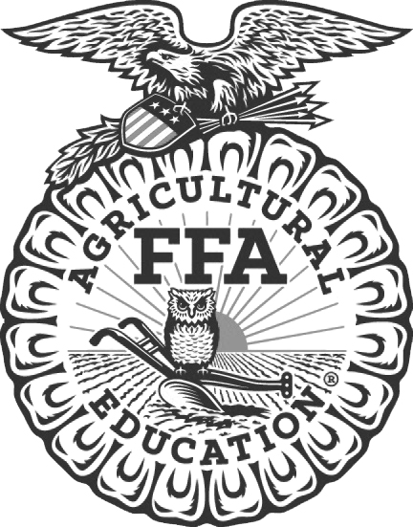

For Immediate Release Contact: Carmen Bracey, State FFA Coordinator

FFA Chapter Participates in State FFA Horse Evaluation Event
Williamston, NC – The _______________________________FFA Chapter participated in the State FFA Horse Evaluation Career Development Event on April 15, 2023, in Martin County, North Carolina. Team members include ___________________________, __________________________, ________________________ and ______________________________. Their FFA Advisor is _________________________________.

At the state event, students demonstrate their ability to reason and communicate about equine selection, management, and production. Participants are responsible for evaluating classes of horses composed of performance and halter. Participants then give oral reasons for their selections.
The highest scoring team in the state event is eligible to compete in the National FFA event at the National FFA Convention in October 2023. The top three teams and high scoring individual will be recognized during the North Carolina FFA State Convention in Raleigh on June 27-29, 2023.
This event is one of 43 different career development events offered to North Carolina FFA members on the state level. The North Carolina Horse Council sponsors the state Horse Evaluation Career Development Event.
North Carolina FFA is a youth organization of 32,597 student members preparing for leadership and careers in the science, business, and technology of agriculture with 355 local chapters across the state. FFA makes a positive difference in the lives of students by developing their potential for premier leadership, personal growth, and career success through agricultural education. Visit www.ncffa.org for more information.

