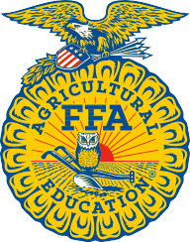

North Carolina FFA Association

NCSU Campus Box 7654 2601 Stinson Drive
4160 Broughton Hall
Raleigh, NC 27695

P (919) 515-4206
F (919) 513-3201
www.ncffa.org
News Release

For Immediate Release Contact: Carmen Bracey, State FFA Coordinator

Local FFA Members Participate in State Event

Sanford, NC – The _________________________ FFA Chapter participated in the State FFA Vet Science Career Development Event on November 19, 2022, at Lee County High School, in cooperation with the Veterinary Technician Program at Central Carolina Community College in Sanford, NC. Team members include ___________________________, ________________________, ____________________________ and ___________________________. Their FFA Advisor is _______________________________.

The winning team will compete at the 95th National FFA Convention in Indianapolis, Indiana next October. The Vet Science CDE participants demonstrate their knowledge in all facets of veterinary science from breed and parasite identification to clinical and handling practicums.

North Carolina FFA is a youth organization of 32,597 student members preparing for leadership and careers in the science, business, and technology of agriculture with 355 local chapters across the state. FFA makes a positive difference in the lives of students by developing their potential for premier leadership, personal growth, and career success through agricultural education. Visit www.ncffa.org for more information.

FFA makes a positive difference in the lives of students by developing their potential for premier leadership, personal growth and career success through agricultural education.

