January 9, 2020
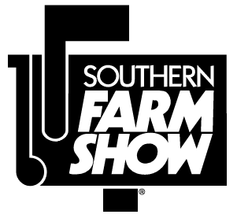

To: Agricultural Education Teachers

From: Joshua Bledsoe, N.C. FFA Association
David Zimmerman, Southern Farm Show

Re: 2020 FFA Tractor and Truck Driving Event at the Southern Farm Show

FFA Day at the Southern Farm Show will be Thursday, February 6, 2020. The Tractor and Truck Driving Events will be held in the James B. Hunt Horse Arena (4601 Trinity Rd, Raleigh, NC). Orientation for the events will begin promptly at 10:00 AM and all participants should be present for the orientation session. We recommend arriving no later than 9:30 AM to ensure enough time to get checked in before orientation.

Each federation may have one participant in each of the events. The chapter advisor must register the one participant ONLINE this year. Please note that by registering online, advisors are certifying that this is the only entry from their federation.
ONLINE REGISTRATION INSTRUCTIONS
PLEASE REGISTER BY January 30, 2020

- Visit ncffa.org and navigate to the Register and Request section (main menu > NC FFA > Register & Request; or underneath the main homepage area, you will see 3 boxes – click on the one that says Register & Request)
- Click on Truck and Tractor Driving CDE Registration
- Email address is required, and you will receive a confirmation email to the address you enter here.
- Chapter Name and Number – enter your chapter name, followed by your chapter number (NCxxxx)
- Federation is required to ensure that each federation only has one participant.
- Select Truck or Tractor from the Event drop-down menu. If you are registering a student for both events, you must complete the form twice.
- Student Name – enter the student’s name as it will appear on the FFA roster so we can verify FFA membership.
- Click Submit when all the applicable fields have been entered and you have printed a copy for your records (optional).
Participant check in will begin at 8:30 AM in the indoor arena of the Hunt Horse Complex. Event judging criteria/rules and course layouts can be found on the NC FFA Career Development Events webpage. The North Carolina FFA Dress Code for this event will be a collared shirt and long pants. T-shirts with FFA emblems and school logos are also acceptable. The NC FFA Tobacco Use Policy will be in effect during this event, which means that tobacco products, Juuls, e-cigarettes, and vapes are not to be used at any time during any official FFA event. Cell phones and other electronic devices are prohibited during the event, including smart watches (Fitbits, Apple Watches, etc.). Violations of these policies will result in penalties as outlined in the 2019-2020 Event Guidelines. Please do not wear opened toed shoes or sandals to avoid injury.
**Student waivers are required for all events. Please complete the attached waiver and submit them at the registration/check-in desk before the start of the event. Students without waivers will NOT be allowed to compete.**

If you have questions about the event, please contact the FFA office.

Registration fees for this event are $10 per student. You will receive an invoice for this event after the competition; please do not bring payment to the event.

The event is projected to be completed by 2:00 PM. Following the completion of the event, trophies will be presented to the top three individuals in each event.

As we continue to invite FFA members to the show, we also ask your assistance in making their visit a good experience, not only for the students, but for the other show guests and exhibitors. To help reduce these problems, suggestions for attending the Southern Farm Show are enclosed.

This year’s show will be an excellent opportunity for students interested in agriculture. If there is anything we can do to make your visit more productive, please give us a call.
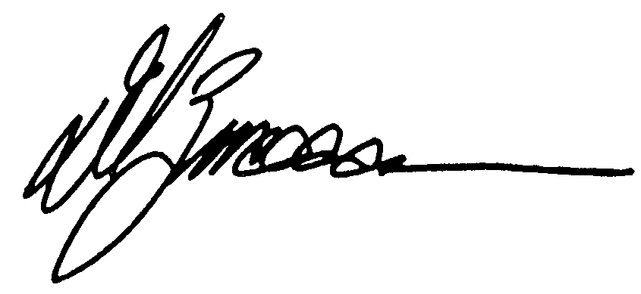

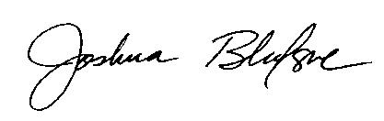

Joshua Bledsoe David Zimmerman
State FFA Advisor Show Manager, Southern Farm Show
(919) 513-1205 (704) 494-7544

Tips for FFA Advisors Bringing Students to the Southern Farm Show:

- Explain to your students what the show is about: That it is a trade show for farmers and agribusiness people. Make sure they understand the importance of the show to exhibiting companies and that interference by anyone can result in business loss for the exhibitor.
- Make the trip to the show a reward for students with a genuine interest in agriculture. Most of the problems associated with students at the show come from students who do not have an interest in agriculture.
- Don’t plan to stay too long. Although farmers with specific needs can easily spend a day at the show, students with no set agenda can see the show in two or three hours. Again, when they are bored is when they get into trouble.
- Give the students an assignment. Ask them to make a list of ten pieces of equipment they saw, who manufactures them, and where they are manufactured. Ask them to list the equipment uses and the cost. A good idea is to get a copy of the show program preprinted in the Southeast Farm Press. Look through the articles and ads and come up with your own project. Please refrain from giving them assignments that involve communication with exhibitors.
- If at all possible, stay with your students, or plan to meet with them at certain times to check on their progress.

Advisor Checklist
To help things go smoothly during registration, please make sure you have completed the following:

Prior to Check-In:

☐ Signed waiver for each participant

☐ Review registration material and Event Guidelines

☐ Check dress code!

☐ No shorts

☐ Closed-toe shoes

☐ No cell phones

☐ No smart watches

☐ No tobacco/vapes

After Check-In:
☐ Have students on the arena floor by 9:55 AM for 10:00 AM orientation

☐ Keep track of your student’s driving order to make sure they are on time for their assigned driving slot.

☐ Please visit the Southern Farm Show but plan to return to the horse arena by 1:30 PM for the event results and trophy presentation.

