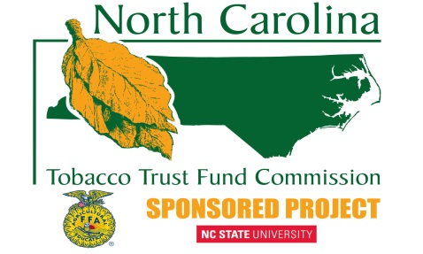
Tobacco Trust Fund Grand Check Presentation
Information Checklist
Please provide the following information by emailing to Gerald Barlowe, gerald_barlowe@ncsu.edu, as soon as possible after confirmation of your check presentation. This information is helpful to our staff and the staff of the Tobacco Trust Fund Grant Commission.
School Name(s) at Presentation:___________________________________________________________
Presentation Date:________________________________
Time of the Presentation:________________________________________________________________
Location of the Presentation: (Include a GPS address)__________________________________________
_____________________________________________________________________________________
Type of Activity: (board of education meeting, FFA meeting, etc)_________________________________
Guests, VIPs Anticipated to Attend and Positions: ____________________________________________
_____________________________________________________________________________________
_____________________________________________________________________________________
Special Circumstances that should be noted:_________________________________________________
_____________________________________________________________________________________

