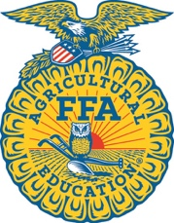
Home School Agricultural Education

North Carolina Agricultural Education
North Carolina FFA Association

Steps to Start Home School Agricultural Education

Step 1
Read the Home School Agricultural Education information documents online.

Step 2
Determine the agricultural education course(s) to use with your student and begin.

Step 3
Complete and mail the registration form and dues included in this packet. Membership cycles start on August 1 each year. Enroll early for a full year’s involvement.

Step 4
Sign up for the NC FFA Listserve for updates and information about statewide FFA activities. Register for statewide events of interest. Determine the local FFA Federation and Region in which you live and reach out to the advisor for a schedule of events.

Step 5
Contact the state Agricultural Education office if you have any questions at 919-513-1205.

