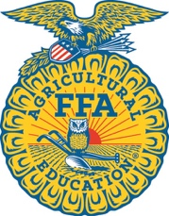
Home School Agricultural Education
North Carolina Agricultural Education/FFA Program

How to Start a Home School Agricultural Education/FFA Instruction

Step 1
Read the Home School Agricultural Education information documents.

Step 2
Determine the course or method of agricultural education instruction you would like to use for your student and begin.

Step 3
Complete and mail the registration form and dues included in this packet. Membership cycles start over on August 1 of each year so enroll early for a full year’s involvement.

Step 4
Sign up for the NC FFA Listserve for updates and information about statewide FFA activities. Register for statewide events of interest. Determine the local FFA Federation and Region in which you live and reach out to the advisor for a schedule of events.

Step 5
Contact the state Agricultural Education office if you have any questions at 919-513-1205.

