Judges Guide

Three (3) of the following Agricultural Mechanics Performance Skills will be selected for the state competition.

The regional rotation guidelines for the two (2) practicums are only a suggestion, and are not mandatory.

Regional rotation for the practicums is as follows. This rotation does NOT apply to State competition:

Odd years - Arc Weld

Even years - MIG weld if available

Odd years - Other practicum choose between 2-7 skills Even years - Other practicum choose between 8-14 skills

# Agricultural Mechanics Performance Skill 1.1 Make a Butt Joint Weld in the Flat Position

Length of metal (L”) and type of welder, STICK or MIG will be determined by event superintendent. At the regional level, any rod can be used for arc weld; state participants will use a 7018.

Participant Name Score Chapter Participant Number

# Instructions to Judges

**You will use the rubric below to grade the participant’s skill for the scenario described.**

The participant will use the proper safety and welding equipment and the electric arc welder OR MIG to perform this skill. Each participant will choose two or three pieces of ¼" x 2" x L" metal. The third piece of metal is optional and may be used for practice and to adjust welder amperage to metal characteristics if so directed by the event superintendent (The practice metal is not required and should not be graded.). In addition, the event superintendent will either provide electrodes needed or allow participants to choose the most appropriate electrodes from choices provided.

The participant will prepare two pieces of ¼" x 2" x L" metal for welding and perform the weld for grading (L" or length in inches may vary and will be determined by the event superintendent.). Multiple electrodes will usually be required to complete the weld. The participant is to place the metal so that the butt joint is formed as a single pass weld along the L" joint in the flat position and is to apply the weld bead evenly to the topside of both metal pieces. The weld will be judged on quality, appearance, penetration, and equal bead placement on both pieces of metal.

# Scoring Directions:

(2 points) Participant used the proper welding helmet with adjustable lens or #10 shaded lens.

(2 points) Participant used proper eye protection at all times.

(1 point) Participant used proper welding gloves.

(2 points) Participant wore proper clothing covering the entire body, including the legs.

(1 point) Participant wore proper leather, closed-toe shoes that left no part of the skin or socks exposed.

(2 points) Participant selected the proper amperage and electrode to match the metal characteristics.

(3 points) Participant’s weld showed no evidence of pores and pits (Defective Weld Chart).

(3 points) Participant’s weld showed no evidence of undercutting (Defective Weld Chart).

(3 points) Participant’s weld showed no evidence of excessive splatter (Defective Weld Chart).

(3 points) Participant’s weld showed even bead placement on both pieces of metal and adequate penetration (Defective Weld Chart).

(3 points) Participant’s weld was uniform in width, thickness, and appearance (Defective Weld Chart).

TOTAL Judges discretion for point deduction explanation.

**Since FFA advisors serve as superintendents on the regional level or below, all chapter FFA advisors must be provided L" by email at least one month prior to Regional Rally. Each advisor must ensure their email is working properly.**

# Agricultural Mechanics Performance Skill 1.2 Make a T Fillet Weld in the Flat Position

Length of metal (L”) and type of welder, STICK or MIG will be determined by event superintendent. At the regional level, any rod can be used for arc weld; state participants will use a 7018.

Participant Name Score Chapter Participant Number

# Instructions to Judges

**You will use the rubric below to grade the participant’s skill for the scenario described.**

The participant will use the proper safety and welding equipment and the electric arc welder OR MIG to perform this skill. Each participant will choose two or three pieces of ¼" x 2" x L" metal. The third piece of metal is optional and may be used for practice and to adjust welder amperage to metal characteristics if so directed by the event superintendent (The practice metal is not required and should not be graded.). In addition, the event superintendent will either provide electrodes needed or allow participants to choose the most appropriate electrodes from choices provided.

The participant will prepare two pieces of ¼" x 2" x L" metal for welding and perform the weld for grading (L" or length in inches may vary and will be determined by the event superintendent.). Multiple electrodes will usually be required to complete the weld. The participant is to place the two pieces of metal so the T-joint is formed and tack weld before rotating them to rest on a 45° jig so that the joint to weld is facing up in the flat position (The event superintendent will provide the jig.). The participant will weld a single pass along the L" length of the upward facing joint, placing the bead evenly on both pieces of the metal. The weld will be judged on quality, appearance, penetration, and equal bead placement on both pieces of metal.

# Scoring Directions:

(2 points) Participant used the proper welding helmet with adjustable lens or #10 shaded lens.

(2 points) Participant used proper eye protection at all times.

(1 point) Participant used proper welding gloves.

(2 points) Participant wore proper clothing covering the entire body, including the legs.

(1 point) Participant wore proper leather, closed-toe shoes that left no part of the skin or socks exposed.

(2 points) Participant selected the proper amperage and electrode to match the metal characteristics.

(3 points) Participant’s weld showed no evidence of pores and pits (Defective Weld Chart).

(3 points) Participant’s weld showed no evidence of undercutting (Defective Weld Chart).

(3 points) Participant’s weld showed no evidence of excessive splatter (Defective Weld Chart).

(3 points) Participant’s weld showed even bead placement on both pieces of metal and adequate penetration (Defective Weld Chart).

(3 points) Participant’s weld was uniform in width, thickness, and appearance (Defective Weld Chart).

TOTAL Judge discretion for point reduction explanation.

**Since FFA advisors serve as superintendents on the regional level or below, all chapter FFA advisors must be provided L" by email at least one month prior to Regional Rally. Each advisor must ensure their email is working properly.**

# Instructions to Judges

**You will use the rubric below to grade the participant’s skill for the scenario described.**

The participant will use the proper safety and welding equipment and the electric arc welder OR MIG to perform this skill. Each participant will choose two or three pieces of ¼" x 2" x L" metal. The third piece of metal is optional and may be used for practice and to adjust welder amperage to metal characteristics if so directed by the event superintendent (The practice metal is not required and should not be graded.). In addition, the event superintendent will either provide electrodes needed or allow participants to choose the most appropriate electrodes from choices provided.

The participant will prepare two pieces of ¼" x 2" x L" metal for welding and perform the weld for grading (L" or length in inches may vary and will be determined by the event superintendent.). Multiple electrodes will usually be required to complete the weld. The participant is to place the metal so the outside corner joint is formed as a single pass weld along the L" joint in the flat position and is to apply the weld bead evenly to the topside of both metal pieces. The weld will be judged on quality, appearance, penetration, and equal bead placement on both pieces of metal.

# Scoring Directions:

(2 points) Participant used the proper welding helmet with adjustable lens or #10 shaded lens.

(2 points) Participant used proper eye protection at all times.

(1 point) Participant used proper welding gloves.

(2 points) Participant wore proper clothing covering the entire body, including the legs.

(1 point) Participant wore proper leather, closed-toe shoes that left no part of the skin or socks exposed.

(2 points) Participant selected the proper amperage and electrode to match the metal characteristics.

(3 points) Participant’s weld showed no evidence of pores and pits (Defective Weld Chart).

(3 points) Participant’s weld showed no evidence of undercutting (Defective Weld Chart).

(3 points) Participant’s weld showed no evidence of excessive splatter (Defective Weld Chart).

(3 points) Participant’s weld showed even bead placement on both pieces of metal and adequate penetration (Defective Weld Chart).

(3 points) Participant’s weld was uniform in width, thickness, and appearance (Defective Weld Chart).

TOTAL Judge discretion for point reduction explanation.

**Since FFA advisors serve as superintendents on the regional level or below, all chapter FFA advisors must be provided L" by email at least one month prior to Regional Rally. Each advisor must ensure their email is working properly.**

# Agricultural Mechanics Performance Skill 1.4 Make a Vertical-Up Butt Joint Weld

Length of metal (L”) and type of welder, STICK or MIG will be determined by event superintendent. At the regional level, any rod can be used for arc weld; state participants will use a 7018.

Participant Name Score Chapter Participant Number

# Instructions to Judges

**You will use the rubric below to grade the participant’s skill for the scenario described.**

The participant will use the proper safety and welding equipment and the electric arc welder OR MIG to perform this skill. Each participant will choose two or three pieces of ¼" x 2" x L" metal. The third piece of metal is optional and may be used for practice and to adjust welder amperage to metal characteristics if so directed by the event superintendent (The practice metal is not required and should not be graded.). In addition, the event superintendent will either provide electrodes needed or allow participants to choose the most appropriate electrodes from choices provided.

The participant will prepare two pieces of ¼" x 2" x L" metal for welding and perform the weld for grading (L" or length in inches may vary and will be determined by the event superintendent.). Multiple electrodes will usually be required to complete the weld. The participant is to place the metal so that the butt joint is formed as a single pass weld along the L" joint in the vertical up position and is to apply the weld bead evenly to the facing side of both metal pieces. The weld will be judged on quality, appearance, penetration, and equal bead placement on both pieces of metal.

# Scoring Directions:

(2 points) Participant used the proper welding helmet with adjustable lens or #10 shaded lens.

(2 points) Participant used proper eye protection at all times.

(1 point) Participant used proper welding gloves.

(2 points) Participant wore proper clothing covering the entire body, including the legs.

(1 point) Participant wore proper leather, closed-toe shoes that left no part of the skin or socks exposed.

(2 points) Participant selected the proper amperage and electrode to match the metal characteristics.

(3 points) Participant’s weld showed no evidence of pores and pits (Defective Weld Chart).

(3 points) Participant’s weld showed no evidence of undercutting (Defective Weld Chart).

(3 points) Participant’s weld showed no evidence of excessive splatter (Defective Weld Chart).

(3 points) Participant’s weld showed even bead placement on both pieces of metal and adequate penetration (Defective Weld Chart).

(3 points) Participant’s weld was uniform in width, thickness, and appearance (Defective Weld Chart).

TOTAL Judge discretion for point reduction explanation.

**Since FFA advisors serve as superintendents on the regional level or below, all chapter FFA advisors must be provided L" by email at least one month prior to Regional Rally. Each advisor must ensure their email is working properly.**

# Agricultural Mechanics Performance Skill 1.5 Make a Lap Joint Fillet Weld in the Flat Position

Length of metal (L”) and type of welder, STICK or MIG will be determined by event superintendent. At the regional level, any rod can be used for arc weld; state participants will use a 7018.

Participant Name Score Chapter Participant Number

# Instructions to Judges

**You will use the rubric below to grade the participant’s skill for the scenario described.**

The participant will use the proper safety and welding equipment and the electric arc welder OR MIG to perform this skill. Each participant will choose two or three pieces of ¼" x 2" x L" metal. The third piece of metal is optional and may be used for practice and to adjust welder amperage to metal characteristics if so directed by the event superintendent (The practice metal is not required and should not be graded.). In addition, the event superintendent will either provide electrodes needed or allow participants to choose the most appropriate electrodes from choices provided.

The participant will prepare two pieces of ¼" x 2" x L" metal for welding and perform the weld for grading (L" or length in inches may vary and will be determined by the event superintendent.). Multiple electrodes will usually be required to complete the weld. The participant will perform the lap joint fillet weld in the flat position as a single pass bead along the L" joint with the bead evenly placed on the top surface of both pieces of the metal. The weld will be judged on quality, appearance, penetration, and equal bead placement on both pieces of metal.

**E7018 electrodes meet industry welding code requirements.**

# Scoring Directions:

(2 points) Participant used the proper welding helmet with adjustable lens or #10 shaded lens.

(2 points) Participant used proper eye protection at all times.

(1 point) Participant used proper welding gloves.

(2 points) Participant wore proper clothing covering the entire body, including the legs.

(1 point) Participant wore proper leather, closed-toe shoes that left no part of the skin or socks exposed.

(2 points) Participant selected the proper amperage and electrode to match the metal characteristics.

(3 points) Participant’s weld showed no evidence of pores and pits (Defective Weld Chart).

(3 points) Participant’s weld showed no evidence of undercutting (Defective Weld Chart).

(3 points) Participant’s weld showed no evidence of excessive splatter (Defective Weld Chart).

(3 points) Participant’s weld showed even bead placement on both pieces of metal and adequate penetration (Defective Weld Chart).

(3 points) Participant’s weld was uniform in width, thickness, and appearance (Defective Weld Chart).

TOTAL Judge discretion for point reduction explanation.

**Since FFA advisors serve as superintendents on the regional level or below, all chapter FFA advisors must be provided L" by email at least one month prior to Regional Rally. Each advisor must ensure their email is working properly.**

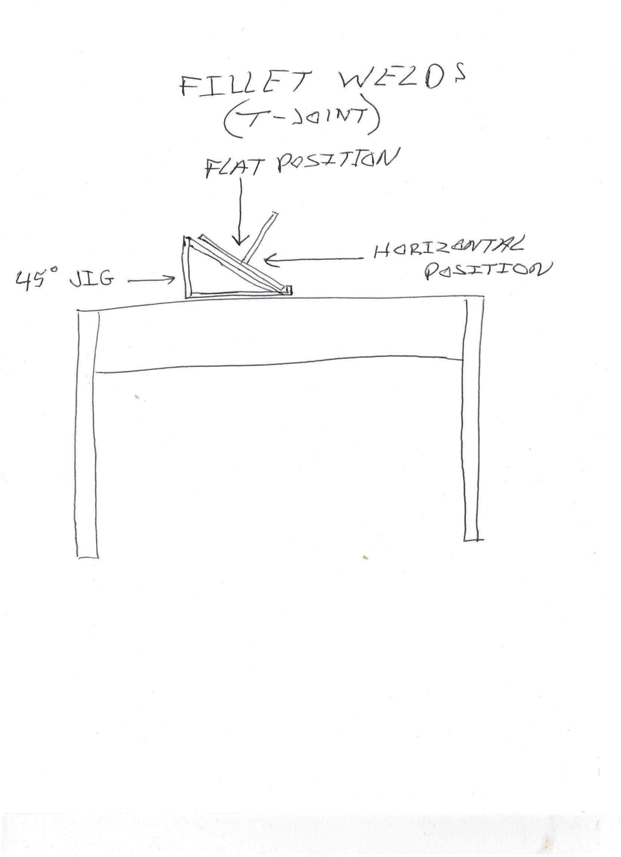

# Sweating a Piece of Copper Pipe into a Fitting

Participant Name Score Chapter Participant Number

# Instructions to Judges

**You will use the rubric below to grade the participant’s skill for the scenario described.**

The participant will wear the proper safety equipment for this activity. The proper tools will be selected and used to cut a piece of copper pipe according to the accompanying diagram (diagram and dimensions are subject to change without notice.). Once the pipe has been cut, it will then be properly prepared and sweated into a copper fitting using the provided propane torch. Upon completion, the participant will use a paint pen to identify his/her product and record answers to questions on Job Sheet.

What is the makeup of the solder? What type of gas is being used?

# Scoring Directions:

(2 points) Proper clothing, gloves, and eye protection were used.

(3 points) Pipe was cut to the given dimensions as shown in the accompanying diagram.

(2 points) Pipe and fitting were properly cleaned in preparation for soldering.

(3 points) Flux was properly applied to the pipe and fitting.

(2 points) Correct answer for makeup of solder.

(2 points) Correct answer for type of gas used.

(3 points) Pipe and fitting were heated properly using the propane torch.

(8 points) Solder was applied in a proper manner to the joint.

(2 points) The joint was properly cooled and identified using the provided paint pen.

TOTAL Judge discretion for point reduction explanation.

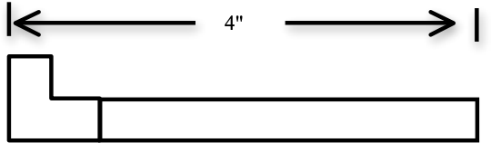

# Use proper tools to properly adjust the valves on an OHV small engine

Participant Name Score Chapter Participant Number

# Instructions to Judges

**You will use the rubric below to grade the participant’s skill for the scenario described.**

Wear the proper safety equipment for this activity. Select and use the proper tools to remove the valve cover, check the valve clearance, and record. Adjust valve clearance as specified by the manufacturer for a provided single cylinder small engine (The appropriate engine manual will be provided.). Reinstall valve cover and use the Job Sheet below to record engine specifications and measurements. Use the measuring tools to perform measurements and record.

**Safety Equipment Needed:**

Safety glasses and/or goggles for use at all times Long pants and proper leather closed-toe shoes

Engine Number:

# Job Sheet Information Engine Evaluation Guide

Engine Model-Series: - Manufacturer’s specification for valve clearance for this engine: intake Manufacturer’s specification for valve clearance for this engine: exhaust Engine’s intake valve clearance before adjustment:

Engine’s exhaust valve clearance before adjustment:

Measurement of diameter of crankshaft end to nearest hundredth: in.

# Scoring Directions:

(2 points) Participant selected and used proper eye protection.

(3 points) Participant selected and used proper tools to remove and install valve cover.

(2 points) Participant correctly identified and recorded on the Job Sheet the engine model number.

(2 points) Participant correctly identified and recorded on the Job Sheet the correct intake valve clearance.

(2 points) Participant correctly identified and recorded on the Job Sheet the correct exhaust valve clearance.

(5 points) Participant selected proper tools, correctly adjusted, and checked the valve clearance for intake valve.

(5 points) Participant selected proper tools, correctly adjusted, and checked the valve clearance for exhaust valve.

(4 points) Participant correctly recorded the correct measurement of crankshaft diameter.

TOTAL Judge discretion for point reduction explanation.

# Use a small engine with head removed to inspect and record piston damage and perform cylinder and piston ring measurements

Participant Name Score Chapter Participant Number

# Instructions to Judges

**You will use the rubric below to grade the participant’s skill for the scenario described.**

Wear the proper safety equipment for this activity. Locate the engine model and serial number and record on the Job Sheet. Select and use the proper tools to examine the piston head for damage, and record results on the Job Sheet. Take measurements of bore of the engine and record. Take measurement of thickness of the piston ring using either the dial caliper or the micrometer. Insert piston ring into top of cylinder and measure ring end gap and record. Use supplied engine manual and determine if ring is in tolerance. Calculate the cubic inch of engine. The participant will submit the Job Sheet to the judge upon completion.

**Safety Equipment Needed:**

Safety glasses and/or goggles for use at all times Long pants and proper leather closed-toe shoes

Engine Number:

Engine Model-Series: - Does piston have damage? Yes/No

# Job Sheet Information Engine Evaluation Guide

Bore of engine: to the nearest hundredth Piston ring thickness: to the nearest hundredth Piston ring end gap: to the nearest hundredth Is the piston ring end gap in tolerance? Yes/No Calculate cubic inch of engine:

# Scoring Directions:

(2 points) Participant selected and used proper eye protection.

(1 point) Participant recorded proper engine model and series number on Job Sheet.

(2 points) Participant correctly inspected and recorded on Job Sheet if engine had evidence of piston damage.

(4 points) Participant properly recorded measurement of cylinder bore.

(4 points) Participant properly recorded measurement of thickness of piston ring.

(4 points) Participant properly recorded piston ring end gap.

(4 points) Participant properly recorded is piston ring in tolerance.

(4 points) Participant properly calculated cubic inch of engine.

Total Judge discretion for point reduction explanation.

# Determine difference in elevation between two points and the distance from the rods to the transit

Participant Name Score Chapter Participant Number

# Instructions to Judges

**You will use the rubric below to grade the participant’s skill for the scenario described.**

Wear the proper safety equipment for this activity. Take two elevation readings from given points and record the findings on the Job Sheet below. Determine the difference in the elevation for the two points and record the difference on the Job Sheet. Use the stadia hairs in the transit OR pacing and determine the distance from the rods to the transit and submit to the judge upon completion of this activity (All readings and recordings should be to the nearest tenth of a foot.).

**Safety Equipment Needed:**

Safety glasses and/or goggles for use at all times Long pants and proper leather closed-toe shoes

# Job Sheet

**Use of Transit Skill**

Elevation Reading on Grade Stick 1 (to the nearest tenth of a foot) Elevation Reading on Grade Stick 2 (to the nearest tenth of a foot) Difference in elevation between Grade Stick 1 and Grade Stick 2 Distance from grade stick 1 to the transit

Distance from grade stick 2 to the transit

# Scoring Directions:

(2 points) Participant selected and used proper eye protection.

(5 points) Participant properly took a reading from first identified grade stick and recorded the findings on the Job Sheet to nearest tenth of foot.

(5 points) Participant properly took a reading from second identified grade stick and recorded the findings on the job sheet to nearest tenth of foot.

(5 points) Participant determined the difference in elevation between the two points to the nearest tenth of foot and recorded the difference of the Job Sheet.

(4 points) Participant determined the distance from the transit to the first identified grade stick and recorded on the Job Sheet.

(4 points) Participant determined the distance from the transit to the second identified grade stick and recorded on the Job Sheet.

Total Judge discretion for point reduction explanation.

# Construct a frame according to specified dimension using designated fasteners

Participant Name Score Chapter Participant Number

# Instructions to Judges

**You will use the rubric below to grade the participant’s skill for the scenario described.**

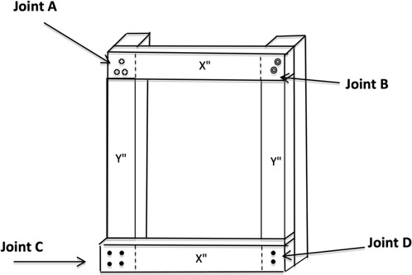The participant will wear the proper safety equipment for this activity. The participant will use the provided equipment and the pre-cut 2” x 4” x 12” pieces of wood and materials to secure, mark, and layout four pieces of lumber according to drawing dimensions. Then the participant will assemble the pieces to form a rectangular frame using the fasteners and pattern specified on the drawing (see the drawing at right).

Length of two boards will be X" and the length of two boards will be Y".

# Scoring Directions:

(2 points) Participant selected and used proper eye protection.

(1 point) Participant secured and layout lumber according to drawing dimensions and design.

(5 points) Participant assembled two pieces of lumber using three appropriate screws in a triangle pattern to attach X length leg to Y length leg. **(Joint A)**

(5 points) Participant assembled third side of frame (Y length leg) using two appropriate bolts in diagonal pattern from outside corner. **(Joint B)**

(5 points) Participant assembled last piece of lumber (X length leg) to one corner of the frame using four appropriate finish nails in a square pattern. **(Joint C)**

(5 points) Participant assembled last piece of lumber (X length leg) to one corner of the frame using two appropriate common nails. **(Joint D)**

(2 points) Participant set finish nails with proper equipment and properly applied filler to holes.

Total Judge discretion for point reduction explanation.

# Agricultural Mechanics Performance Skill 7

**Properly light, adjust, use, and shut down the oxy-fuel system to cut steel plate**

Participant Name Score Chapter Participant Number

# Instructions to Judges

You will use the rubric below to grade the participant’s skill in cutting a section of to-be-determined thickness steel plate to specified dimensions (to be determined by judge) so that the finished cut exhibits the signs of a proper cut and is cut straight according to the squared soapstone mark. Participant must look at chart to determine Oxygen and Acetylene pressures given the tip size.

1. **Use of proper safety equipment (STOP any participant who does not have proper safety equipment)**

(1 point) Participant selected and used proper welding goggles with number 5 shaded lens and welding gloves.

(1 point) Participant wore proper clothing and footwear to perform the activity.

1. **Adjusting regulator pressures – THE ORDER THAT STEPS ARE PERFORMED IN THIS SECTION DOES NOT MATTER: STUDENTS SHOULD NOT BE PENALIZED FOR THE ORDER SKILLS ARE PERFORMED IN**

(1 point) Participant opened the fuel cylinder 1/3 to 1/2 turns.

(1 point) Participant opened the oxygen cylinder fully.

Participant adjusted the fuel regulator valve to about 5 pounds per square inch **(Range given – varies with the tip. May be required to check chart. See attached chart to determine pressure settings.).**

(2 points)

**Proper Acetylene pressure according to chart?**

Participant adjusted the oxygen regulator valve for 10 – 20 pounds per square inch **(Range given – varies with the tip. May be required to check chart. See attached chart to determine pressure settings.).**

(2 points)

**Proper Oxygen pressure according to chart?**

1. **Lighting the torch – THE ORDER OF STEPS SHOULD BE FOLLOWED; DEDUCTIONS INCURRED IF NOT FOLLOWED**

(1 point) Participant opened the fuel gas valve on the torch 1/4 turn and lit the torch with a spark lighter.

(1 point) Participant adjusted the fuel flow until the smoke cleared the flame.

(1 point) Participant opened the oxygen valve on the torch and adjusted the flame to neutral (clean the tip if necessary).

(1 point) Participant pressed the cutting lever and held open while readjusting to a neutral flame.

1. **Cutting steel plate with the oxy-­-fuel torch**

(1 point) Participant used square and soapstone to properly mark the steel plate for cutting.

(1 point) Participant controlled torch in the proper position to preheat steel plate.

Participant cut the steel plate maintaining proper tip clearance and speed so as to avoid a melted top edge or

(3 points)

gouges indicating too slow travel or rough edges and incomplete cut from traveling too fast and finished with a straight, square, smoothed face cut with drag lines bending slightly backward at the bottom.

(2 points) Participant’s cut was straight and to the proper dimensions per instructions.

1. **Shutoff of the torch – THIS ORDER OF STEPS SHOULD BE FOLLOWED. CONTESTANTS SHOULD BE STOPPED IF THEY FAIL TO FOLLOW THESE STEPS AND DEDUCTIONS SHOULD BE INCURRED**

(1 point) Participant turned off oxygen valve on the torch.

(1 point) Participant turned off fuel gas valve on the torch.

1. **Shutdown the system and purge the lines – ORDER SHOULD BE FOLLOWED WITH NO PENALTY**

(1 point) Participant turned off the fuel gas cylinder valve.

Participant opened fuel gas torch valve to bleed off fuel gas line until all pressure was relieved in both gauges on regulator and then backed out the regulator adjusting screw (turned left) before closing the fuel gas torch valve.

(1 point)

(1 point) Participant turned off oxygen cylinder valve.

Participant opened the oxygen valve on the torch and bled off the oxygen line until no pressure was indicated

(1 point)

on either gauge on regulator and then backed out the regulator adjusting screw before closing the oxygen torch valve.

**TOTAL SCORE Judge discretion for point reduction explanation.**

# Sample Chart for Skill 7

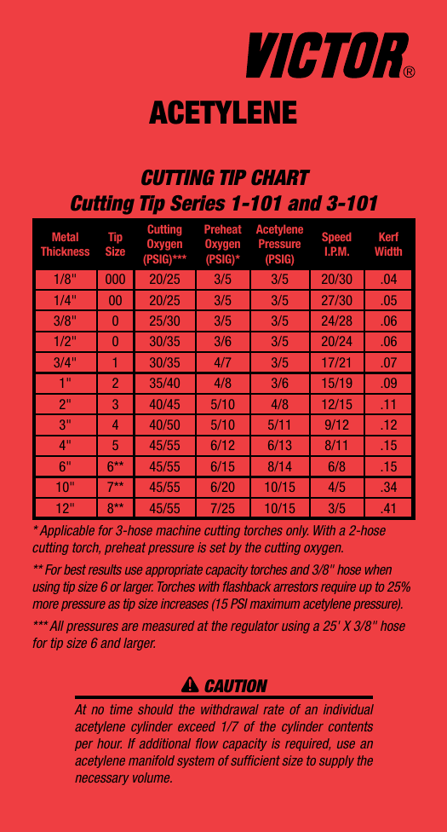

**Agricultural Mechanics Performance Skill 8**

# Wire a light fixture controlled by a single-pole switch in the middle of a run with the power coming to the light fixture first before proceeding to a duplex receptacle that will remain hot at all times

Participant Name Score Chapter Participant Number

# Instructions to Judges

**You will use the rubric below to grade the participant’s skill for the scenario described.**

The participant will use the proper safety equipment, nonmetallic sheathed cable (NMS cable), electrical devices, wire nuts, “Stacon” wire connectors (if provided), and wiring tools to properly wire a light fixture controlled by a single-pole switch in the middle of a run with the power coming to the light fixture first before proceeding to a duplex receptacle that will remain hot at all times.

# Scoring Directions:

(2 points) Participant selected and used proper safety equipment at all times.

(2 points) Participant selected the most appropriate nonmetallic sheathed cable, devices, “Stacons” (connectors) and/or wire nuts to complete the assigned task.

(2 points) Participant stripped approximately 3/4" from the ends of insulated wires from needed cables.

(4 points) Participant made ground wire connections “at the light fixture box” by twisting together three ground (bare) wires from power source, single-pole switch, and duplex receptacle with the light fixture ground and attached with the proper size wire nut or “Stacon.” If the fixture has a grounding wire screw, a grounding wire nut is used so the loose end of the ground is connected and wrapped to the light fixture grounding screw (When wire nuts or “Stacon” wire connectors are used, an additional pigtail wire may be needed.).

(2 points) Participant marked the “switch-leg” 2-wire NMS cable white (neutral) wire from the light fixture to the single- pole switch with black tape at both the switch and light fixture ends.

(3 points) Participant made black (hot) wire connections at the single-pole switch by connecting and wrapping the white (black taped) wire and black wire (both are hot) from the “switch-leg” 2-wire NMS cable to the single-pole switch hot terminal screws and the ground wire to the grounding single-pole switch terminal screw.

(2 points) Participant properly connected the “switch-leg” 2-wire NMS cable wire from the single-pole switch “at the light fixture” with the white wire with black tape from the single-pole switch connected to the brass terminal of the light fixture and the black wire from the single-pole switch connected to all remaining black (hot) wires in the fixture box (includes power source and receptacle NMS cable hot wires).

(4 points) Participant stripped approximately 3/4" from each end of 6- to 8-inch piece of white (neutral) pigtail wire, connected and wrapped one end of white (neutral) pigtail wire to the silver terminal screw on the light fixture, and properly twisted and connected the opposite end of white (neutral) pigtail wire to remaining white wires “at the light fixture box” with the appropriate wire nut (includes power source and receptacle NMS neutral wires).

(2 points) Participant properly attached 2-wire NMS cable to receptacle with the black (hot) wire connected to a duplex receptacle brass terminal and the white (neutral) wire connected to a duplex receptacle silver terminal and ground wire connected to the duplex receptacle grounding screw.

(2 points) Participant checked each wire nut connection for tightness by holding the wire nut and pulling on individual wires.

TOTAL Judge discretion for point reduction explanation.

# Teachers’ diagram to train participants for Skill 8 Participants are not allowed to have this diagram during competition.

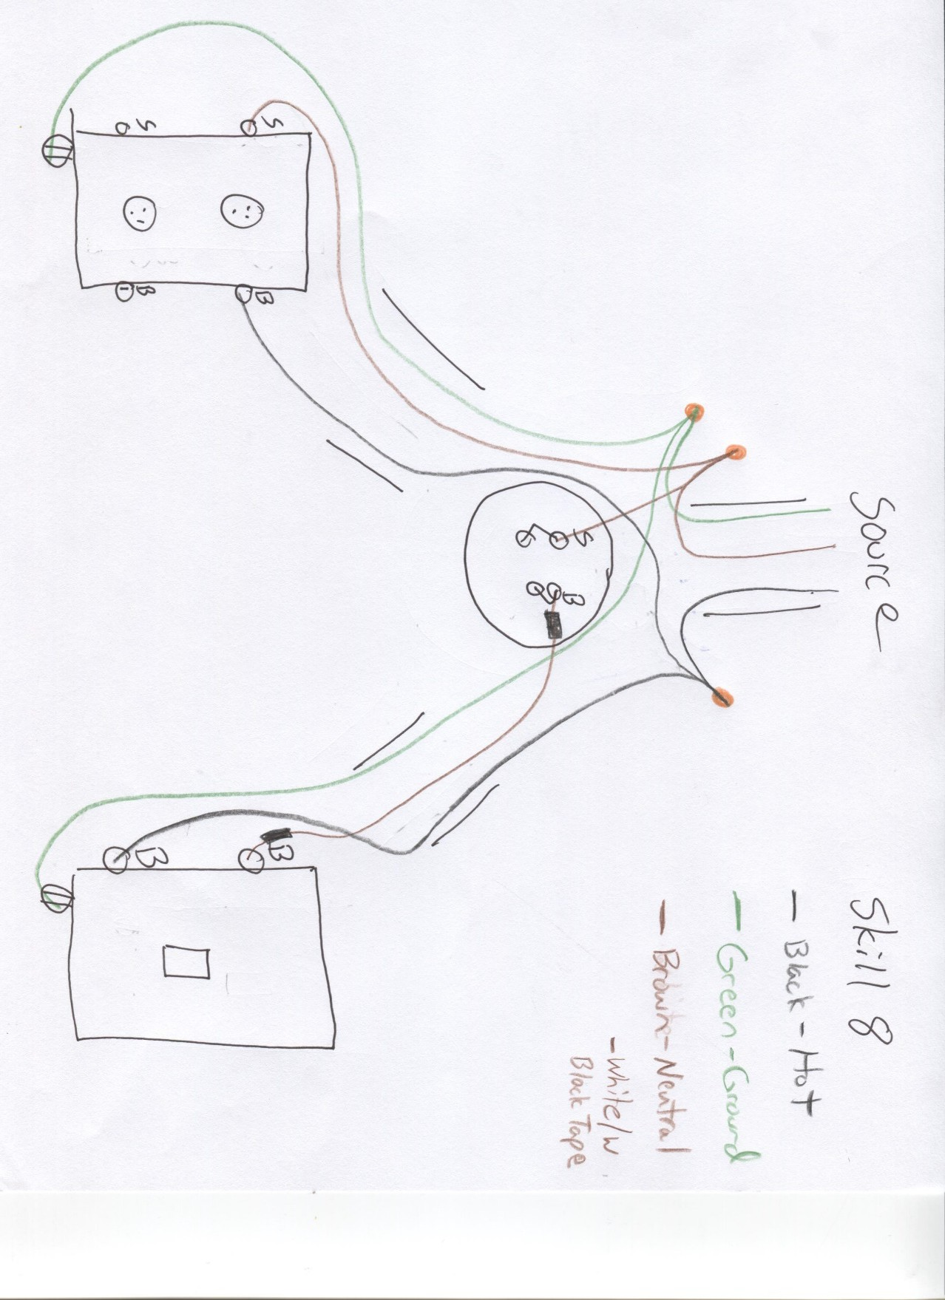

**Agricultural Mechanics Performance Skill 9**

## Wire a light fixture controlled by a single-pole switch with the power being first supplied to the single-pole switch.

**The student will include a duplex receptacle beyond the light fixture which is to remain hot at all times.**

Participant Name Score Chapter Participant Number **Instructions to Judges**

## You will use the rubric below to grade the participant’s skill for the scenario described.

The participant will use the proper safety equipment, nonmetallic sheathed cable (NMS cable), electrical devices, wire nuts, “Stacon” wire connectors (if provided), and wiring tools to properly wire a light fixture controlled by a single-pole switch with the power being first supplied to the single-pole switch while a duplex receptacle beyond the light remains hot at all times.

## Scoring Directions:

(2 points) Participant selected and used proper safety equipment at all times.

(2 points) Participant selected the most appropriate NMS cable (both two-wire and three-wire are required), devices, “Stacons” (connectors) and/or wire nuts to complete the assigned task.

(2 points) Participant stripped approximately 3/4" from the ends of insulated wires from needed cables.

(4 points) Participant made ground wire connections “at the switch box” and “at the light fixture box” by twisting ground (bare) wires together from 2-wire NMS cable and 3-wire NMS cable and attaching the proper size grounding wire nuts so that the loose ends of the grounds were wrapped and connected to the grounding screws on the single-pole switch and light fixture (When wire nuts or “Stacons” are used, an additional 6- to 8-inch piece of ground (bare) pigtail wires may be needed to make connection to the electrical device grounding screws. In some cases, light fixtures will not have a grounding screw but a grounding wire that requires wire nutting to the loose end of ground wire.).

(1 point) Participant made white (neutral) wire connections “at the single-pole switch box” by twisting white (neutral) wires together from 2-wire NMS cable and the 3-wire NMS cable and securing with the proper size wire nut.

(3 points) Participant made black (hot) wire connections “at the switch box” by twisting black (hot) wires together from 2- wire NMS cable and the 3-wire NMS cable with a 6- to 8-inch black (hot) pigtail wire and securing with the proper size wire nut so that loose end of black (hot) pigtail wire was wrapped and connected to one of (hot) single-pole switch terminal screws.

(2 points) Participant properly wrapped and connected one end of red wire from 3-wire NMS cable to one of (hot) single- pole switch terminals screws and the other end of red wire to the light fixture brass terminal screw.

(3 points) Participant made white (neutral) wires connections “at the light fixture box” by twisting together white (neutral) wires for 2-wire NMS cable from receptacle, the 3-wire NMS cable, and light fixture 6- to 8-inch white (neutral) pigtail wire and securing with the proper size wire nut so that the loose end of the white (neutral) pigtail wire was wrapped and connected to the light fixture silver terminal screw.

(1 point) Participant made black (hot) wire connections “at the light fixture box” by twisting together the black wire from the 3-wire NMS cable to the switch and the black wire from the 2-wire NMS cable to the receptacle securing with the proper size wire nut.

(3 points) Participant connected and wrapped ground wire from 2-wire NMS cable “at the duplex receptacle box” to the grounding screw on the duplex receptacle, connected and wrapped the white (neutral) wire from 2-wire NMS cable “at the duplex receptacle box” to a silver terminal screw on the duplex receptacle, and connected and wrapped the black (hot) wire from 2-wire NMS cable “at the duplex receptacle box” to a brass terminal screw on the duplex receptacle.

(2 points) Participant checked each wire nut connection for tightness by holding the wire nut and pulling on individual wires.

TOTAL Judge discretion for point reduction explanation.

# Teachers’ diagram to train participants for Skill 9 Participants are not allowed to have this diagram during competition.

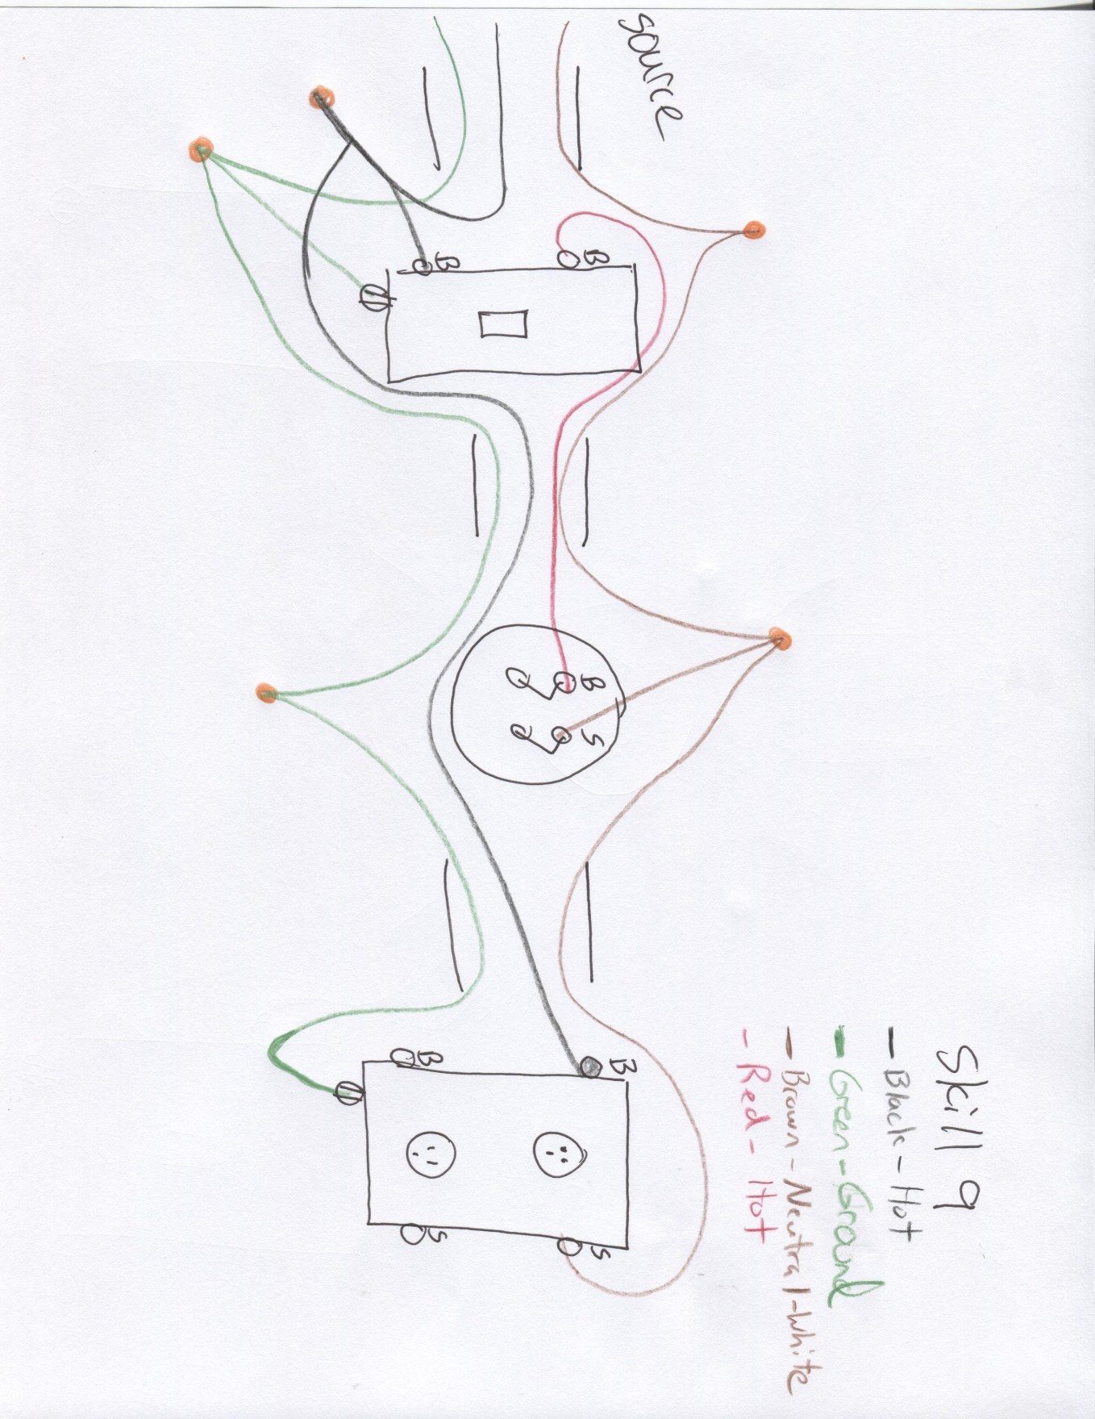

**Agricultural Mechanics Performance Skill 10**

# Wire a light fixture controlled by three-way switches when the power is first supplied to one of the switches and with the light located between the switches

Participant Name Score Chapter Participant Number

# Instructions to Judges

**You will use the rubric below to grade the participant’s skill for the scenario described.**

The participant will use the proper safety equipment, nonmetallic sheathed cable (NMS cable), electrical devices, wire nuts, “Stacon” wire connectors (if provided), and wiring tools to properly wire a light fixture controlled by two three-way switches with the power being first supplied to one of the three-way switches.

# Scoring Directions:

(2 points) Participant selected and used proper safety equipment at all times.

(2 points) Participant selected the most appropriate NMS cable (both two-wire and three-wire are required), devices, “Stacons” (connectors) and/or wire nuts to complete the assigned task.

(2 points) Participant stripped approximately 3/4" from the ends of insulated wires from needed cables.

(3 points) Participant made ground wire connections at the switch boxes and at the light fixture box by twisting ground (bare) wires together from 2-wire NMS cable and 3-wire NMS cable and attaching the proper size grounding wire nuts so that the loose ends of the grounds were wrapped and connected to the grounding screws on the three-way switches and light fixture (When wire nuts or “Stacons” are used, an additional 6- to 8-inch piece of ground (bare) pigtail wires must be used to make connection to the electrical device grounding screws. In some cases, light fixtures will not have a grounding screw but a grounding wire that requires wire nutting to the loose end of ground wire.).

(1 point) Participant made white (neutral) wire connections at the first three-way switch box by twisting white (neutral) wires together from 2-wire NMS power source cable and the 3-wire NMS cable to light and attaching the proper size wire nut to secure the connection.

(3 points) Participant connected black (hot) wire from 2-wire NMS power source cable to the common screw on first three-way switch.

(2 points) Participant connected 3-wire NMS cable from light to the first three-way switch by wrapping and attaching the red wire and black wire to the traveler terminal screws on the first three-way switch.

(3 points) Participant connected white (neutral) wire at the light fixture box by wrapping and attaching white (neutral) wire for 3- wire NMS cable from first three-way switch to the silver terminal screw on the light fixture.

(2 points) Participant made black (hot) wire connections at the light fixture box by twisting together and attaching the proper size wire nut to the black wire from the 3-wire NMS cable to the first switch and the hot wire (white wire coded for hot) from the 3-wire NMS cable going to the second three-way switch.

(3 points) Participant wrapped and connected the black (hot) from 3-wire NMS cable to the common terminal screw on the second three-way switch, wrapped and connected the hot wire (white wire coded for hot) and the red wire to the traveler terminal screws on the second three-way switch.

(2 points) Participant checked each wire nut connection for tightness by holding the wire nut and pulling on individual wires.

TOTAL Judge discretion for point reduction explanation.

# Teachers’ diagram to train participants for Skill 10 Participants are not allowed to have this diagram during competition.

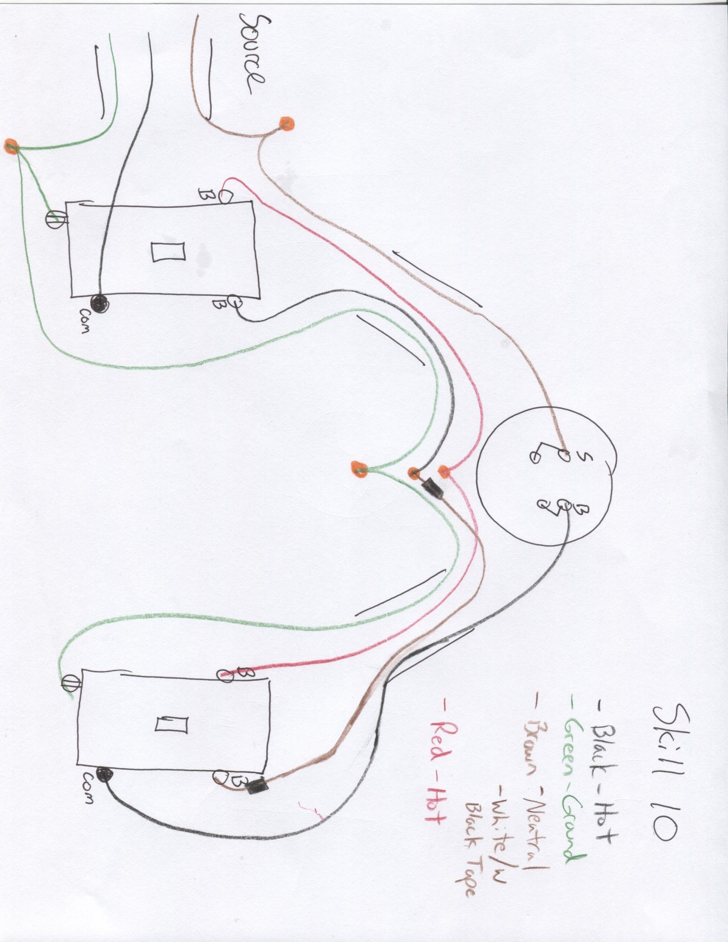

**Agricultural Mechanics Performance Skill 11**

# Wire a GFCI receptacle with multiple-location protection

Participant Name Score Chapter Participant Number

# Instructions to Judges

**You will use the rubric below to grade the participant’s skill for the scenario described.**

The participant will use the proper safety equipment, nonmetallic sheathed cable (NMS cable), electrical devices, wire nuts, “Stacon” wire connectors (if provided), and wiring tools to properly wire a GFCI duplex receptacle so that the down-line single- pole switch and light fixture are GFCI protected.

# Scoring Directions:

(2 points) Participant selected and used proper safety equipment at all times.

(2 points) Participant selected the most appropriate NMS cable, devices, “Stacons” (connectors) and/or wire nuts to complete the assigned task.

(2 points) Participant stripped approximately 3/4" from the ends of insulated wires from needed cables.

(3 points) Participant made ground wire connections “at the GFCI receptacle box” by twisting ground (bare) wires together from 2-wire NMS power source cable to GFCI receptacle with 2-wire NMS cable to down-line single-pole switch securing with the proper size grounding wire nut so that the loose end of the ground wire was wrapped and connected to the grounding screw on the GFCI receptacle (If a grounding wire nut for grounding is not used a 6- to 8-inch piece of ground (bare) pigtail wire may be necessary.). Participant made ground wire connections “at the single-pole switch box” for 2-wire NMS cable from GFCI duplex receptacle and 2-wire NMS cable to the light fixture in the same way.

(3 points) Participant made white (neutral) wire connection “at the GFCI receptacle box” from 2-wire NMS power source cable to the GFCI receptacle by wrapping and connecting the loose end to the silver line screw terminal on the GFCI receptacle. Participant made white (neutral) wire connection “at the GFCI receptacle box” from 2-wire NMS cable to the single-pole switch by wrapping and connecting the loose end to the silver load screw terminal on the GFCI receptacle.

(3 points) Participant made black (hot) wire connection “at the GFCI receptacle box” from 2-wire NMS power source cable to the GFCI receptacle by wrapping and connecting the loose end to the brass line screw terminal on the GFCI receptacle.

Participant made black (hot) wire connection “at the GFCI receptacle box” from 2-wire NMS cable to the single-pole switch by wrapping and connecting the loose end to the brass load screw terminal on the GFCI receptacle.

(2 points) Participant made white (neutral) wire connections “at the single-pole switch box” by twisting white (neutral) wires together from 2-wire NMS cable to GFCI duplex receptacle and 2-wire NMS cable to the light fixture securing with the proper size wire nut.

(3 points) Participant made black (hot) wire connections “at the single-pole switch box” from 2-wire NMS cable to the GFCI duplex receptacle and 2-wire NMS to the light fixture by separately wrapping and connecting the loose ends of each wire to the two brass common screw terminals on the single-pole switch.

(3 points) Participant made connection “at the light fixture box” from 2-wire NMS to the single-pole switch by wrapping and connecting the black (hot) wire to the brass screw terminal on the light and the white (neutral) wire to the silver screw terminal on the light. (Sometimes connections may be made to white and black wire leads from the light fixture).

(2 points) Participant checked each wire nut connection for tightness by holding the wire nut and pulling on individual wires.

TOTAL Judge discretion for point reduction explanation.

# Teachers’ diagram to train participants for Skill 11 Participants are not allowed to have this diagram during competition.

Line and load on receptacle will be marked.

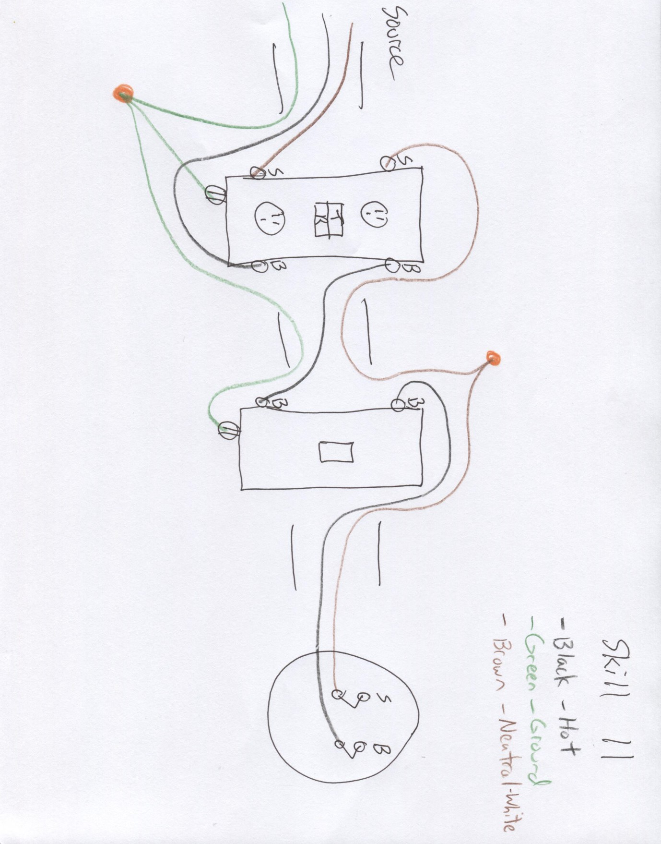

# Agricultural Mechanics Performance Skill 12

**Wire a 240-volt welder plug and receptacle after selecting proper gauge wire from scenario and chart**

Participant Name Score Chapter Participant Number

# Instructions to Judges

**You will use the rubric below to grade the participant’s skill for the scenario described.**

Wear the proper safety equipment at all times for this activity. Use the non-metallic sheathed cable (NMS cable), electrical devices, wire nuts, “Stacon” wire connectors (if provided), and wiring tools to complete this wiring exercise in accordance with the diagram given below. Leave all connections outside the boxes as if waiting for electrical inspection. Prior to leaving the area, ask the judge to inspect all work.

Select proper gauge wire *using the chart* to obtain a amp current using copper wire and allowing for a 2% drop to run a 240-volt welder with type wire with a feet run of wire. (Blanks to be determined by judge.)

Example: Select proper gauge wire using the chart to obtain a 30-amp current using copper wire and allowing for a 2% drop to run a 240-volt welder with type TW cable with a 50-feet run of wire. Answer: 10 gauge

What gauge wire is needed for above scenario?

# Scoring Directions:

(2 points) Participant used proper safety procedures.

(2 points) Participant stripped correct 3/4” from end of wire.

(3 points) Participant selected proper wire size for the scenario.

(3 points) Participant properly grounded plug by connecting green wire to oval terminal of plug.

(3 points) Participant properly connected neutral wire to bottom L terminal of plug.

(3 points) Participant properly connected both hot wires (red and black) to each side of plug.

(3 points) Participant properly grounded receptacle by connecting green wire to oval terminal of receptacle.

(3 points) Participant properly connected neutral wire to bottom L terminal of receptacle.

(3 points) Participant properly connected both hot wires (red and black) to each side of receptacle.

TOTAL Judge discretion for point reduction explanation.

# Teachers’ diagram to train participants for Skill 12 Participants are not allowed to have this diagram during competition.

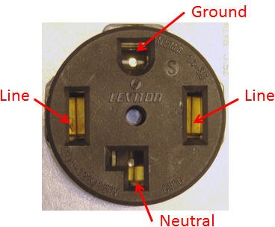

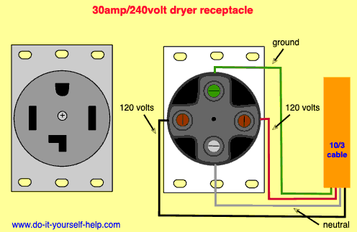

**Chart for Skill 12**

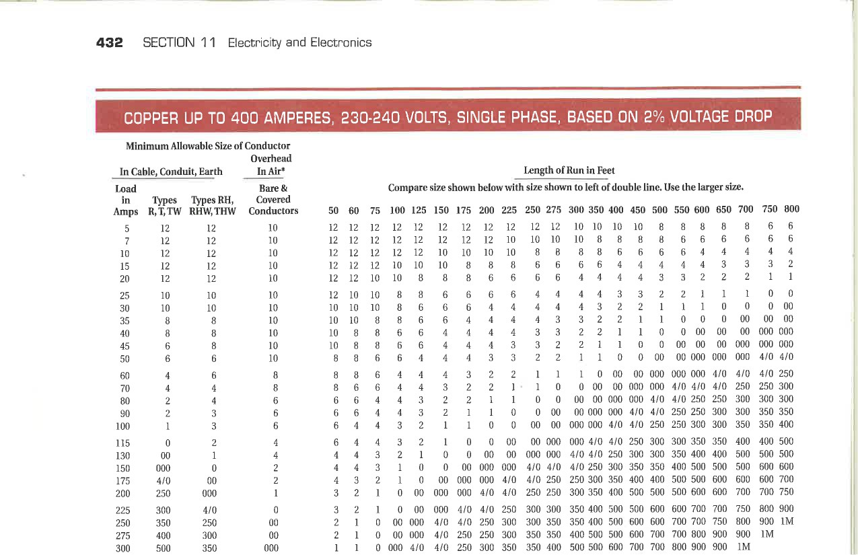

# Use multimeter to perform various skills

Participant Name Score Chapter Participant Number

# Instructions to Judges

**You will use the rubric below to grade the participant’s skill for the scenario described.**

Wear the proper safety equipment at all times for this activity.

Use the multimeter and choose the proper setting to determine the voltage of the battery.

Use the multimeter and choose the proper setting to test the fuse and determine the resistance of the fuse. Use the multimeter and choose the proper setting to test the continuity of the piece of wire.

Calculate the amps using the readings if the battery and fuse were in a circuit. I=V/R

# Scoring Directions:

(2 points) Proper safety precautions and equipment were used during activity.

(3 points) Participant placed the leads of the multimeter in the correct jacks.

(2 points) Participant selected the correct voltage setting on the multimeter.

(4 points) Participant recorded the correct voltage of the battery.

(2 points) Participant selected the correct ohm setting to test the fuse on the multimeter.

(4 points) Participant recorded the correct resistance of the fuse.

(2 points) Participant selected the correct setting to test continuity on the multimeter.

(3 points) Participant recorded the correct answer to the continuity of the wire.

(3 points) Participant correctly calculated amps of the circuit.

TOTAL Judge discretion for point reduction explanation.

# Agricultural Mechanics Performance Skill 14

**Use tap and die and chart to select proper tap, die, and perform skill**

Participant Name Score Chapter Participant Number

# Instructions to Judges

**You will use the rubric below to grade the participant’s skill for the scenario described.**

Wear the proper safety equipment at all times for this activity. Use the provided equipment and materials to select, secure, and perform the correct tap into the ¼ x ¾ x 2-inch block and perform the correct die onto the ¼ x 4-inch rod and make threads 1 inch long. Answer questions on Job Sheet.

What size drill was used in the block for you to tap the hole for the ” UNC/UNF tap provided? (tap size and thread pitch to be determined by judge)

fractional

decimal

Thread the block using the correct tools available to you.

What size die will you need to use to thread UNC/UNF (thread pitch determined by judge) threads on the ¼ inch rod? Thread the rod using the correct tools available to you.

# Scoring Directions:

(2 points) Proper safety precautions were used during this activity.

(1 point) Proper tools were used to perform the skills.

(2 points) Participant properly recorded fractional drill size on Job Sheet.

(2 points) Participant properly recorded letter drill size on Job Sheet.

(3 points) Participant chose the correct tap.

(5 points) Participant correctly threaded block with no thread breaks.

(2 points) Participant properly recorded the correct size die on Job Sheet.

(3 points) Participant chose the correct die.

(5 points) Participant correctly threaded rod 1” with no thread breaks.

TOTAL Judge discretion for point reduction explanation.

# Chart for Skill 14