Biotech Terminology and Math

 | Unit/Competency/Objective | Cognitive | Performance
 | BIOTECH TERMINOLOGY AND MATH
EB01.00 | Apply the language and math of biotechnology. | 5%
EB01.01 | Define terms common to the field of biotechnology. | 2%
EB01.02 | Identify roots, prefixes and suffixes used in biotechnology. | 1%
EB01.03 | Use metric math and the 24 hour clock. | 2%

Unit Materials

EB01.01 Content ⬥ Biotechnology Terms
Quiz ⬥ Biotechnology Terminology Quiz
Teacher Tool ⬥ Biotechnology Terminology Quiz Key
Activity ⬥ Biotechnology Terms Puzzle
Teacher Tool ⬥ Biotechnology Terms Puzzle Key
EB01.02 Content ⬥ Biotechnology Roots, Prefixes and Suffixes
Activity ⬥ Roots, Prefixes and Suffixes Challenge
Activity ⬥ Roots, Prefixes and Suffixes Puzzle
Teacher Tool ⬥ Roots, Prefixes and Suffixes Puzzle Key
EB01.03 Content ⬥ Biotech Math Conversion Chart
Activity ⬥ Biotech Math Pretest
Teacher Tool ⬥ Biotech Math Pretest Key
Activity ⬥ Around the House

Recommended Resource

First Edition
Author: Louise Simmers
ISBN #: 1401858090
©2004 Publish Date: 1/5/2004
Binding: Hardcover
Pages: 340
Publisher: Delmar Learning

Lesson Plan

EB01.01 Define terms common to the field of biotechnology.

Activity | Steps | Comments
Flash Cards | - Give students a copy of the list of terms and have them create flash cards writing the word on one side of the card and the definition on the other. When appropriate, have students write the definition in their own words.  - In pairs, allow students to “study” their flash cards for 15 minutes. Then give the terminology quiz and allow students to work in pairs to complete the quiz. | - The teacher should keep index cards available for students who cannot supply their own.  - Students learn when they write out their flash cards and then use them as a study aid.  - Note that in the quiz the definition is not exactly as written on the terminology list. This is a purposeful attempt to help students transfer learning. Quiet discussion should be allowed during the quiz.
Terminology Puzzle | - Have students complete the terminology puzzle, either alone or in pairs, without the aid of the terminology list. | - This activity helps in learning to spell Biotech terms.
Homework | - Assign students to ask a parent, guardian or sibling to help study the flash cards (terminology) for 15 minutes.  - Then, write a one paragraph summary of the experience on notebook paper and have the person who helped the student study – sign the paper.  - Students should turn in their paragraph at the beginning of the class following the assignment. | - Encourage students to take note of the reaction to the words being learned, and the questions asked by the person who helps the student study. This assignment gives the student an opportunity to share a little about what he/she is learning, and helps the parent (guardian or sibling) contribute to the students’ learning.

EB01.02 Identify roots, prefixes and suffixes used in biotechnology.

Activity | Steps | Comments
Flash Cards | - Give students a copy of the list of terms and have them create flash cards writing the word on one side of the card and the definition on the other. When appropriate, have students write the definition in their own words.  - In pairs, allow students to “study” their flash cards for 15 minutes. | - The teacher should keep index cards available for students who cannot supply their own.  - Students learn when they write out their flash cards and then use them as a study aid.  - Chapter 7 of Health Science Career Exploration includes a more expansive list of terms and good illustration of human body root words.
Roots, Prefixes and Suffixes Challenge | - Divide the class into groups of 3-5 students per group.  - Given the list of Roots, Prefixes and Suffixes Challenge, give teams 10 minutes to fill in as many blanks as possible. | - Instructions for the activity and scoring directions are given at the top of the Roots, Prefixes and Suffixes Challenge form.  - During the scoring process, reinforce the meaning of the root, prefix or suffix.
Roots, Prefixes and Suffixes Puzzle | - Copy and distribute the Roots, Prefixes and Suffixes puzzle. | - This activity would be suitable as a homework assignment.

EB01.03 Use metric math and the 24 hour clock.

Activity | Steps | Comments
Biotech Math Pretest | - Give the Biotech Math Pretest  - Provide each student with a copy of the Biotech Math Conversion Chart and ask students to grade their own pretest. | - Explain that the purpose of the pretest is to help you understand how much they already know about the metric system and 24 hour clock.  - Allowing the students to grade their own test helps them learn how to use the conversion chart.  - Collect the tests and evaluate student knowledge. Adjust instruction as necessary.  - Chapter 8 of Health Science Career Exploration is an excellent unit on math skills with good illustrations, charts and review questions.
Biotech Math Conversion Chart | - Have students create flash cards for the abbreviations and conversions they should commit to memory.  - Give students class time to quiz each other using their flash cards. | - For most students, flash cards are an effective learning tool when specific content is to be memorized.
Measuring Activities | 1. Create a worksheet for students to measure water, etc. in the classroom using measuring devices in the lab.  2. Give students a copy of the Around the House activity for homework. | - This activity helps students become familiar with various measuring devices in the lab.

Biotechnology Terms
Content

Amino acid
The building blocks of a protein molecule. A protein is composed of a chain of hundreds or thousands of amino acids.
Bioinformatics
The use of computers and information technology to gain a new understanding of biology.
Bioprocessing
A technique in which microorganisms, living cells, or their components are used to produce a desired end product.
Bioreactor
A container used for bioprocessing.
Cell
The smallest unit of living organisms that is able to grow and reproduce independently.
Chromosome
Threadlike structures in a cell nucleus that contain genetic information.
Clone
A cell or collection of cells containing identical genetic material. Clones are produced from a single parent cell and are genetically identical to the parent.
Culture
The growth of living organisms in a prepared medium or media.
DNA (deoxyribonucleic acid)
The chemical molecule that is the basic genetic material found in all cells.
Enzyme
A protein that accelerates the rate of chemical reactions. They convert complex proteins, sugars and fat molecules to simpler substances.
Fermentation
A chemical activity using microorganisms to decompose materials (carbohydrates). Fermentation is a specific type of bioprocessing.
Gene
A small section of a chromosome that controls heredity characteristics.
Genetic engineering
Artificially changing the genetic makeup of an organism.
Genome
The total hereditary material of a cell.
Hybrid
In selective breeding, it usually refers to the offspring of two different species or strains.
Mutation
When an organism is changed or altered from its parent or original form.
Nucleic acid
A biological molecule composed of a long chain of nucleotides. All DNA is made from four different nucleotides that. like a four-letter alphabet, are arranged in a variety of different orders. .
Phenotypes
The observable characteristic of an organism as opposed to the set of genes it possesses (its genotype). The physical appearance.
Plasmid
A small, circular piece of DNA found outside the chromosome in bacteria. Plasmids are the principal tools for inserting new genetic information into microorganisms or plants.
Protein
A complex biological molecule composed of a chain of units called amino acids. They carry out the functions of an organism, such as growth and repair of tissue.

Biotechnology Terminology Quiz
Quiz

- The smallest structural unit of a living organism is a ____________________.
- _______________________________ involves splicing different pieces of genetic information together to form new genetic codes or sequences.
- What complex proteins catalyze specific biochemical reactions in living cells?
____________________________________
- What molecules made up of amino acids carry out bodily functions for the growth and repair of body tissue?
____________________________________
- The building blocks of proteins are ___________________________________.
- ________________________ is a term applied to genes, cells or entire organisms that are derived from, and are genetically identical to, a single common ancestor gene, cell or organism.
- What chemical activity uses microorganisms to decompose biomass materials?
____________________________________
- What is the molecule that carries genetic information for biological organisms?
____________________________________
- ______________________________ occurs when an organism has been altered from its original form.
- A vessel used for bioprocessing is a ____________________________________.
- _____________________________________ involves the use of computers and data in biological research.
- The total hereditary material of a cell is a _______________________________.

Biotechnology Terminology Quiz - KEY
Teacher Tool

- The smallest structural unit of a living organism is a CELL.
- GENETIC ENGINEERING involves splicing different pieces of genetic information together to form new genetic codes or sequences.
- What complex proteins catalyze specific biochemical reactions in living cells?
ENZYMES
- What molecules made up of amino acids carry out bodily functions for the growth and repair of body tissue?
PROTEINS
- The building blocks of proteins are AMINO ACIDS.
- CLONE is a term applied to genes, cells or entire organisms that are derived from, and are genetically identical to, a single common ancestor gene, cell or organism.
- What chemical activity uses microorganisms to decompose biomass materials?
FERMENTATION
- What is the molecule that carries genetic data for biological organisms?
DEOXYRIBONUCLEIC ACID - DNA
- MUTATION occurs when an organism has been altered from its original form.
- A vessel used for bioprocessing is a BIOREACTOR.
- BIOINFORMATICS involves the use of computers and data in biological research.
- The total hereditary material of a cell is a GENOME.

Biotechnology Terms Puzzle
Activity

Unscramble each word. Then use the marked letters to solve the second puzzle.

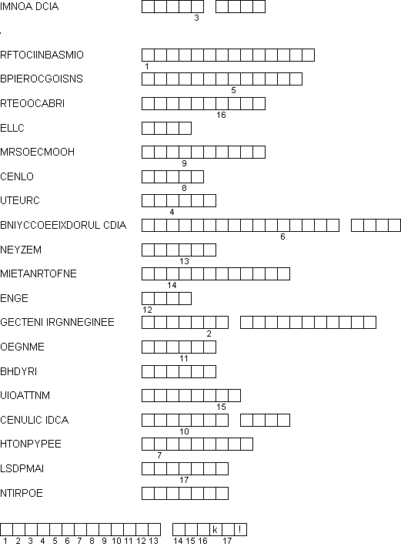

Biotechnology Terms Puzzle - KEY
Teacher Tool

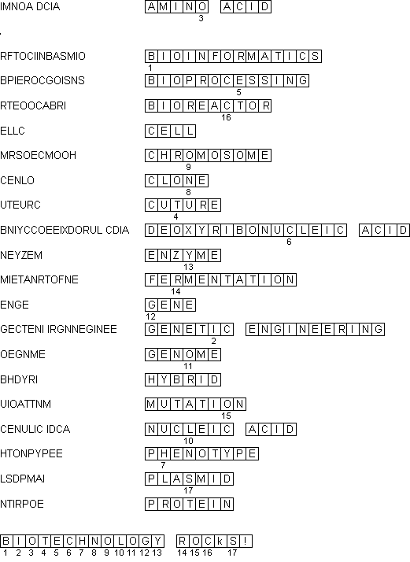

Biotechnology Roots, Prefixes and Suffixes
Content

ROOTS

- bio life
biotechnology
carcin cancer carcinogen
chem drug, chemical biochemical
cryo freezing cryopreservation
cyte cell cytoplasm
forens courts of law forensics
genic, genetic origin, producing genetics
pharm chemicals, drugs pharmaceuticals
med medical biomedical
mutat change mutation
tech modification of
natural science, tool technology
therm heat thermochemical
PREFIXES
a-, an- without, lack of anaerobic
anti - against antibody
aqua- water aquaculture
auto- self autoimmune
bi- twice, double, both bisect
eu- normal eugenics
extra- outside extracellular
intra- inside intracellular
micro- small microbe
mono- one monoclonal
patho- disease producing pathogen
poly- much, many polyclonal
toxi- harmful, poisonous toxic
trans- across transgenic
SUFFIXES
–able capable of biodegradable
–ase enzyme lipase
–al pertaining to microbial
–cide causing death herbicide
–degrade break down biodegradable
–ic pertaining to pathogenic
–ologist someone who studies biotechnologist
–ology study of biology
–scope examining instrument microscope
Roots, Prefixes and Suffixes Challenge
Your teacher will assign you to groups. You will have 10 minutes to fill in as many blanks as possible with a word that uses that particular root, prefix or suffix. You may NOT use any of the examples on the Roots, Prefixes and Suffixes handout.
Scoring Rules
Your teacher will be the judge if a word is allowable. (It must be a real word.)
If your group is the only group to use the word, you earn 5 points.
If two groups use the word it’s worth 3 points.
If more than two groups use the word each group will earn 1 point.
A blank or disqualified word earns 0 points.
ROOTS
bio ___________________
carcin ___________________
chem ___________________
cryo ___________________
cyte ___________________
forens ___________________
genic ___________________
pharm ___________________
med ___________________
mutat ___________________
tech ___________________
therm ___________________
PREFIXES
a-, an- ___________________
anti - ___________________
aqua- ___________________
auto- ___________________
bi- ___________________
eu- ___________________
extra- ___________________
intra- ___________________
micro- ___________________
mono- ___________________
patho- ___________________
poly- ___________________
toxi- ___________________
trans- ___________________
SUFFIXES
–able ___________________
–ase ___________________
–al ___________________
–cide ___________________
–degrade ___________________
–ic ___________________
–ologist ___________________
–ology ___________________
–scope ___________________
TEAM SCORE ____________
Roots, Prefixes and Suffixes Puzzle
Complete the puzzle using the clues shown below.
EMBED PBrush
Across 20. self 6. against 25. disease
1. origin or producing 22. freezing 9. harmful or poisonous 28. normal
4. causing death 23. medical 10. water
5. chemicals or drugs 26. much or many 12. across
7. small 27. enzyme 13. break down
8. unusual change 29. tool 14. twice or double
10. without or lack of 15. study of
11. inside Down 17. examining instrument
14. life 2. drug or chemical 19. outside
16. capable of 3. heat 21. one
18. courts of law 4. cancer 24. cell
Roots, Prefixes and Suffixes Puzzle - KEY
EMBED PBrush
Across 20. self 6. against 25. disease
1. origin or producing 22. freezing 9. harmful or poisonous 28. normal
4. causing death 23. medical 10. water
5. chemicals or drugs 26. much or many 12. across
7. small 27. enzyme 13. break down
8. unusual change 29. tool 14. twice or double
10. without or lack of 15. study of
11. inside Down 17. examining instrument
14. life 2. drug or chemical 19. outside
16. capable of 3. heat 21. one
18. courts of law 4. cancer 24. cell
Biotech Math Conversion Chart
Length
1 meter = 100 centimeters
1 meter = 1000 millimeters
10 millimeters = 1 centimeterVolume for Fluids
1 liter = 1000 milliliters
1 milliliter = 1 cubic centimeter
10 centiliters = 1 deciliter
10 deciliters = 1 literWeightWeight Conversion1 gram = 1000 milligrams
1 kilogram = 1000 grams1 kilogram = 2.2 pounds
1 pound = 16 ounces
Terms and abbreviations
Gram (g) measures mass or weight
Liter (l) measures volume or liquid
Meter (m) measures length or distance
Kilo (k) = thousands
Deci (d) = tenths
Centi (c) = hundredths
Milli (m) = thousandths
24 Hour Clock
Hours are numbered from 0-24. No need to use a.m. or p.m. designations. For example:
1 am = 0100
3:30 am = 0330
10 am = 1000
12 noon = 1200
1 pm = 1300
2:30 pm = 1430
8 pm = 2000
10:15 pm = 2215
12 MN = 2400
Name ____________________________________ Date _________________
Biotech Math Pretest
Fill in the blanks with the correct answer. You may use a calculator.
200 cm = __________ m
5 cm = __________ mm
1 kg = __________ gm
2 gm = __________ mg
1000 ml = __________ liter
1 ml = __________ cc
40 centiliters = __________ deciliters
10 kg = __________ lbs
100 lbs = _________ kg 45.5
1 kg = __________ ounces 35.2
2 pounds = __________ ounces
What is the abbreviation for Kilo? __________
What is the abbreviation for Milli? __________
Using the 24 hour clock, what time is 1300? __________ pm
Using the 24 hour clock, what time 8 pm? __________
Biotech Math Pretest - KEY
Fill in the blanks with the correct answer. You may use a calculator.
200 cm = 2 m
5 cm = 50 mm
1 kg = 1000 gm
2 gm = 2000 mg
1000 ml = 1 liter
1 ml = 1 cc
40 centiliters = 4 deciliters
500C = 1220F
100 lbs = 45.5 kg
1 kg = 35.2 ounces
2 pounds = 32 ounces
What is the abbreviation for Kilo? k
What is the abbreviation for Milli? m
Using the 24 hour clock, what time is 1300? 1 pm
Using the 24 hour clock, what time 8 pm? 2000
Around the House
Look around the house for household items. Record the name of the product and the weight or volume in both the metric measure and household measures. Two examples are given for you.
ProductMetricHouseholdMen’s Aftershave100 ml3.4 fl ozDiet Coke2 liters67.6 fl oz1.2.3.4.5.6.7.8.9.10.
Were you able to recognize the abbreviations used on most of the products? _________
Were there any abbreviations used that you were not familiar with? ______
If yes, what were they, and were you able to figure out what they meant?
Did you learn anything from this activity?

