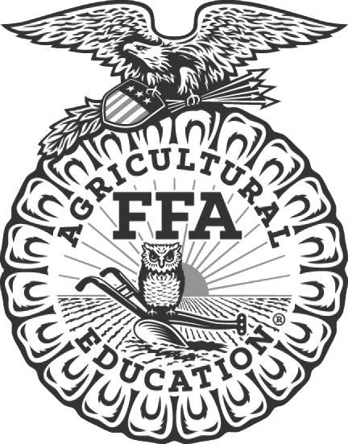

For Immediate Release Contact: Carmen Bracey, State FFA Coordinator

FFA Members Participate in FFA Legislative & Citizenship Day

Raleigh, North Carolina – Members from the ________________________________ FFA Chapter participated in the FFA Legislative & Citizenship Day conducted by the North Carolina FFA Association on February 28, 2023.

The purpose of this event is to expose and educate students on state government, current issues, citizenship, advocacy, and civic engagement. Students that participate in this conference are not only the future leaders of our organization, but citizens and leaders in our state. FFA Legislative & Citizenship Day is a great opportunity for FFA members to develop their potential as leaders for the future of agriculture.

One of the highlights from this conference was a panel discussion about current issues in agriculture, and hearing from speakers about the positive impact of advocacy. Students concluded the event with a visit to the State Capitol to visit with their elected representatives.

North Carolina FFA is a youth organization of 32,597 student members preparing for leadership and careers in the science, business, and technology of agriculture with 355 local chapters across the state. FFA makes a positive difference in the lives of students by developing their potential for premier leadership, personal growth, and career success through agricultural education. Visit www.ncffa.org for more information.

The North Carolina FFA Association is a resource and support organization that does not select, control, supervise, or approve local chapter or individual member activities, except as expressly provided for in the North Carolina FFA Constitution and Bylaws.

