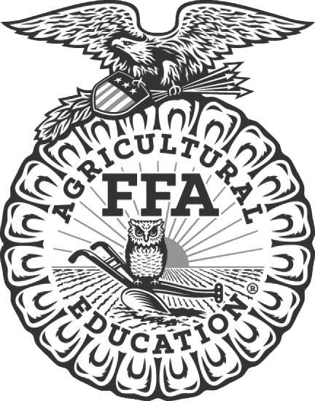
News Release

North Carolina FFA Association
NC State University
Campus Box 7654
Raleigh, NC 27695-7654
Telephone: 919-515-4206
Fax: 919-515-3201
NC FFA website: www.ncffa.org

For Immediate Release Contact: Carmen Bracey, State FFA Coordinator
FFA Chapter Participates in State FFA Livestock Evaluation Event
Raleigh, NC – The _________________________________ participated in the 2022 North Carolina FFA Livestock Evaluation Career Development Event on December 1, 2022 in Raleigh, North Carolina. This event is sponsored by the North Carolina Cattlemen’s Association and the Wilkes Community College Animal Science Department. Team members include ____________________________________, ___________________________________, ___________________________________, and ____________________________________. Their FFA Advisor is _______________________________.
At the state event, participants are scored based on how well they apply livestock evaluation skills learned in the classroom. Each team evaluates eight classes of animals including classes of breeding cattle, market cattle, breeding sheep, market lambs, market swine, breeding swine, and breeding goats. They must also defend the reasoning behind their evaluations to a panel of judges. Participants also complete a written test and work collaboratively in a team keep/cull activity. Completing these activities successfully requires a good understanding of both animal science and herd management skills.
The highest scoring team in the state event is eligible to compete in the National FFA event at the National FFA Convention in October 2023. The top three teams and high scoring individual will be recognized during the North Carolina FFA State Convention in Raleigh on June 27-29, 2023.

North Carolina FFA is a youth organization of 32,597 student members preparing for leadership and careers in the science, business, and technology of agriculture with 355 local chapters across the state. FFA makes a positive difference in the lives of students by developing their potential for premier leadership, personal growth, and career success through agricultural education. Visit www.ncffa.org for more information.

The North Carolina FFA Association is a resource and support organization that does not select, control, supervise, or approve local chapter or individual member activities, except as expressly provided for in the North Carolina FFA Constitution and Bylaws.

