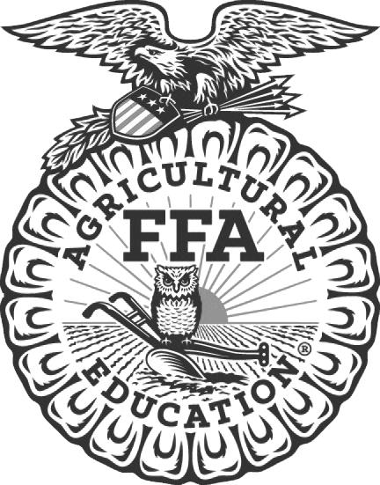
News Release

North Carolina FFA Association
NC State University
Campus Box 7654
Raleigh, NC 27695-7654
Telephone: 919-515-4206
Fax: 919-513-3201
NC FFA website: www.ncffa.org

For Immediate Release Contact: Carmen Bracey, State FFA Coordinator
FFA Chapter Participates in State FFA Livestock Evaluation Event
Raleigh, NC – The _________________________________ FFA chapter participated in the 2022 North Carolina FFA Junior Livestock Evaluation Career Development Event on December 1, 2022 in Raleigh, North Carolina. This event is sponsored by the North Carolina Cattlemen’s Association and the Wilkes Community College Animal Science Department. Team members include Team members include ____________________________________, ___________________________________, ___________________________________ and ____________________________________. Their FFA Advisor is _______________________________.
At the state event, participants are scored based on how well they apply livestock evaluation skills learned in the classroom. Each team evaluates six classes of animals including one class each of breeding cattle, market cattle, breeding sheep, market sheep or lambs, market swine, and breeding swine. They must also defend the reasoning behind their evaluations to a panel of judges. Completing these activities successfully requires a good understanding of both animal science and herd management skills.
This division encourages younger FFA Members in grades 6-10 to compete against their peers while learning more about the senior division event. The top three teams and high scoring individual will be recognized during the North Carolina FFA State Convention in Raleigh on June 27-29, 2023.
North Carolina FFA is a youth organization of 32,597 student members preparing for leadership and careers in the science, business, and technology of agriculture with 355 local chapters across the state. FFA makes a positive difference in the lives of students by developing their potential for premier leadership, personal growth, and career success through agricultural education. Visit www.ncffa.org for more information.

The North Carolina FFA Association is a resource and support organization that does not select, control, supervise, or approve local chapter or individual member activities, except as expressly provided for in the North Carolina FFA Constitution and Bylaws.

