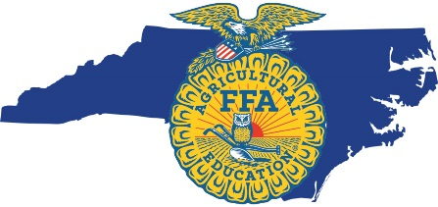
North Carolina Agricultural Education SAE for All Grant
Sponsored by The Universal Leaf Foundation
The Universal Leaf Foundation will strategically invest in supporting local agricultural education programs that are focusing on expanding SAE for All opportunities for students - specifically in the areas of school-based enterprises and service-learning activities.
Agricultural education programs are able to apply for a grant of up to $1,000.
Applications are due Friday, October 29, 2021. Agricultural education programs in the northeast, southeast, and east central agricultural education regions will receive first consideration. Please submit completed applications to ncffafoundation@ncsu.edu. Recipients will be notified
by Wednesday, December 1, 2021.

Chapter Name:
Chapter Advisor:
Advisor Email:
Chapter Address:

Chapter Advisor
Phone:
Chapter Social
Media:
County:

Which SAE for All focus area does your project most align with? (school-based enterprises, service-learning activities)

______________________________________________________________________________________
FFA Advisor Signature Date

______________________________________________________________________________________
Principal Signature Date
Project Name: Describe the project in 1-2 sentences.

Project Description: Please describe the project in detail and how the funding will serve as an extra benefit to promoting SAE for All to all students in your program.

Project Benefits: What are the desired learning outcomes for your students? Describe how students will benefit and if this project has long-term benefits to the school and/or community.

For questions, please contact:
North Carolina FFA Foundation
(919) 513-2017
ncffafoundation@ncsu.edu

Required Grant Summary:
In order to best gather information on how each grant is executed, we require that each recipient submit the following:
1) A minimum of 3 pictures that showcase how the funds have been used.
2) A written summary of how the funds have been used (not to exceed one page). Please describe what the students learned and how the funds benefited the school and community.
The grant summary is due to the NC FFA Foundation (ncffafoundation@ncsu.edu) by Tuesday, March 1, 2022. If the project has not been completed and is scheduled for a later date, please inform us so we may consider a grant summary extension.

