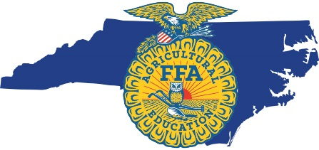
North Carolina FFA
Chapter Improvement Grant
Sponsored by The Universal Leaf Foundation
The Universal Leaf Foundation will strategically invest in supporting local FFA Chapters that work to grow leaders, build communities, and strengthen agriculture. FFA Chapters are able to apply for up to $1,000.00 in grant funds that provide educational benefits to all students in the agricultural education program. Priority will be given to proposals related to the areas of biodiversity, agricultural safety, and environmental stewardship.
Applications are due Monday, December 16, 2019. FFA Chapters in the northeast, southeast, and east central agricultural education regions will receive first consideration. Please submit completed applications to ncffafoundation@ncsu.edu. Recipients will be notified
by Friday, December 20, 2019.

Chapter Name:
Chapter Advisor:
Advisor Email:
Chapter Address:

Chapter Advisor
Phone:
Chapter Social
Media:
County:

Which focus area does your project most align with? (biodiversity, agricultural safety, environmental stewardship)
______________________________________________________________________________________
FFA Advisor Signature Date

______________________________________________________________________________________
FFA Chapter President Signature Date

Project Name: Describe the project in 1-2 sentences.

Project Description: Please describe the project in detail and how the funding will serve as an extra benefit to your FFA chapter.

Project Benefits: What are the desired learning outcomes for your students? Describe the classes that will benefit this semester/year and if this project has long-term benefits to the school and/or community.

For questions, please contact:
North Carolina FFA Foundation
(919) 513-2017
ncffafoundation@ncsu.edu

Required Grant Summary:
In order to best gather information on how each grant is executed, we require that each recipient submit the following:
1) A minimum of 3 pictures that showcase how the funds have been used.
2) A written summary of how the funds have been used (not to exceed one page). Please describe what the students learned and how the funds benefited the school and community.
The grant summary is due to the NC FFA Foundation (ncffafoundation@ncsu.edu) by Monday, March 2, 2020. If the project has not been completed and is scheduled for a later date, please inform us so we may consider a grant summary extension.

