FFA and Agricultural Education in North Carolina - Quick Facts

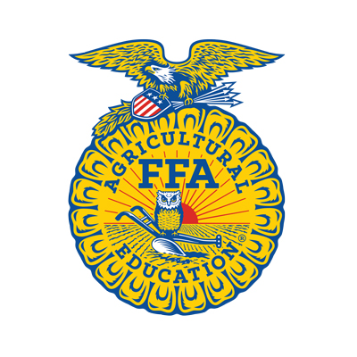

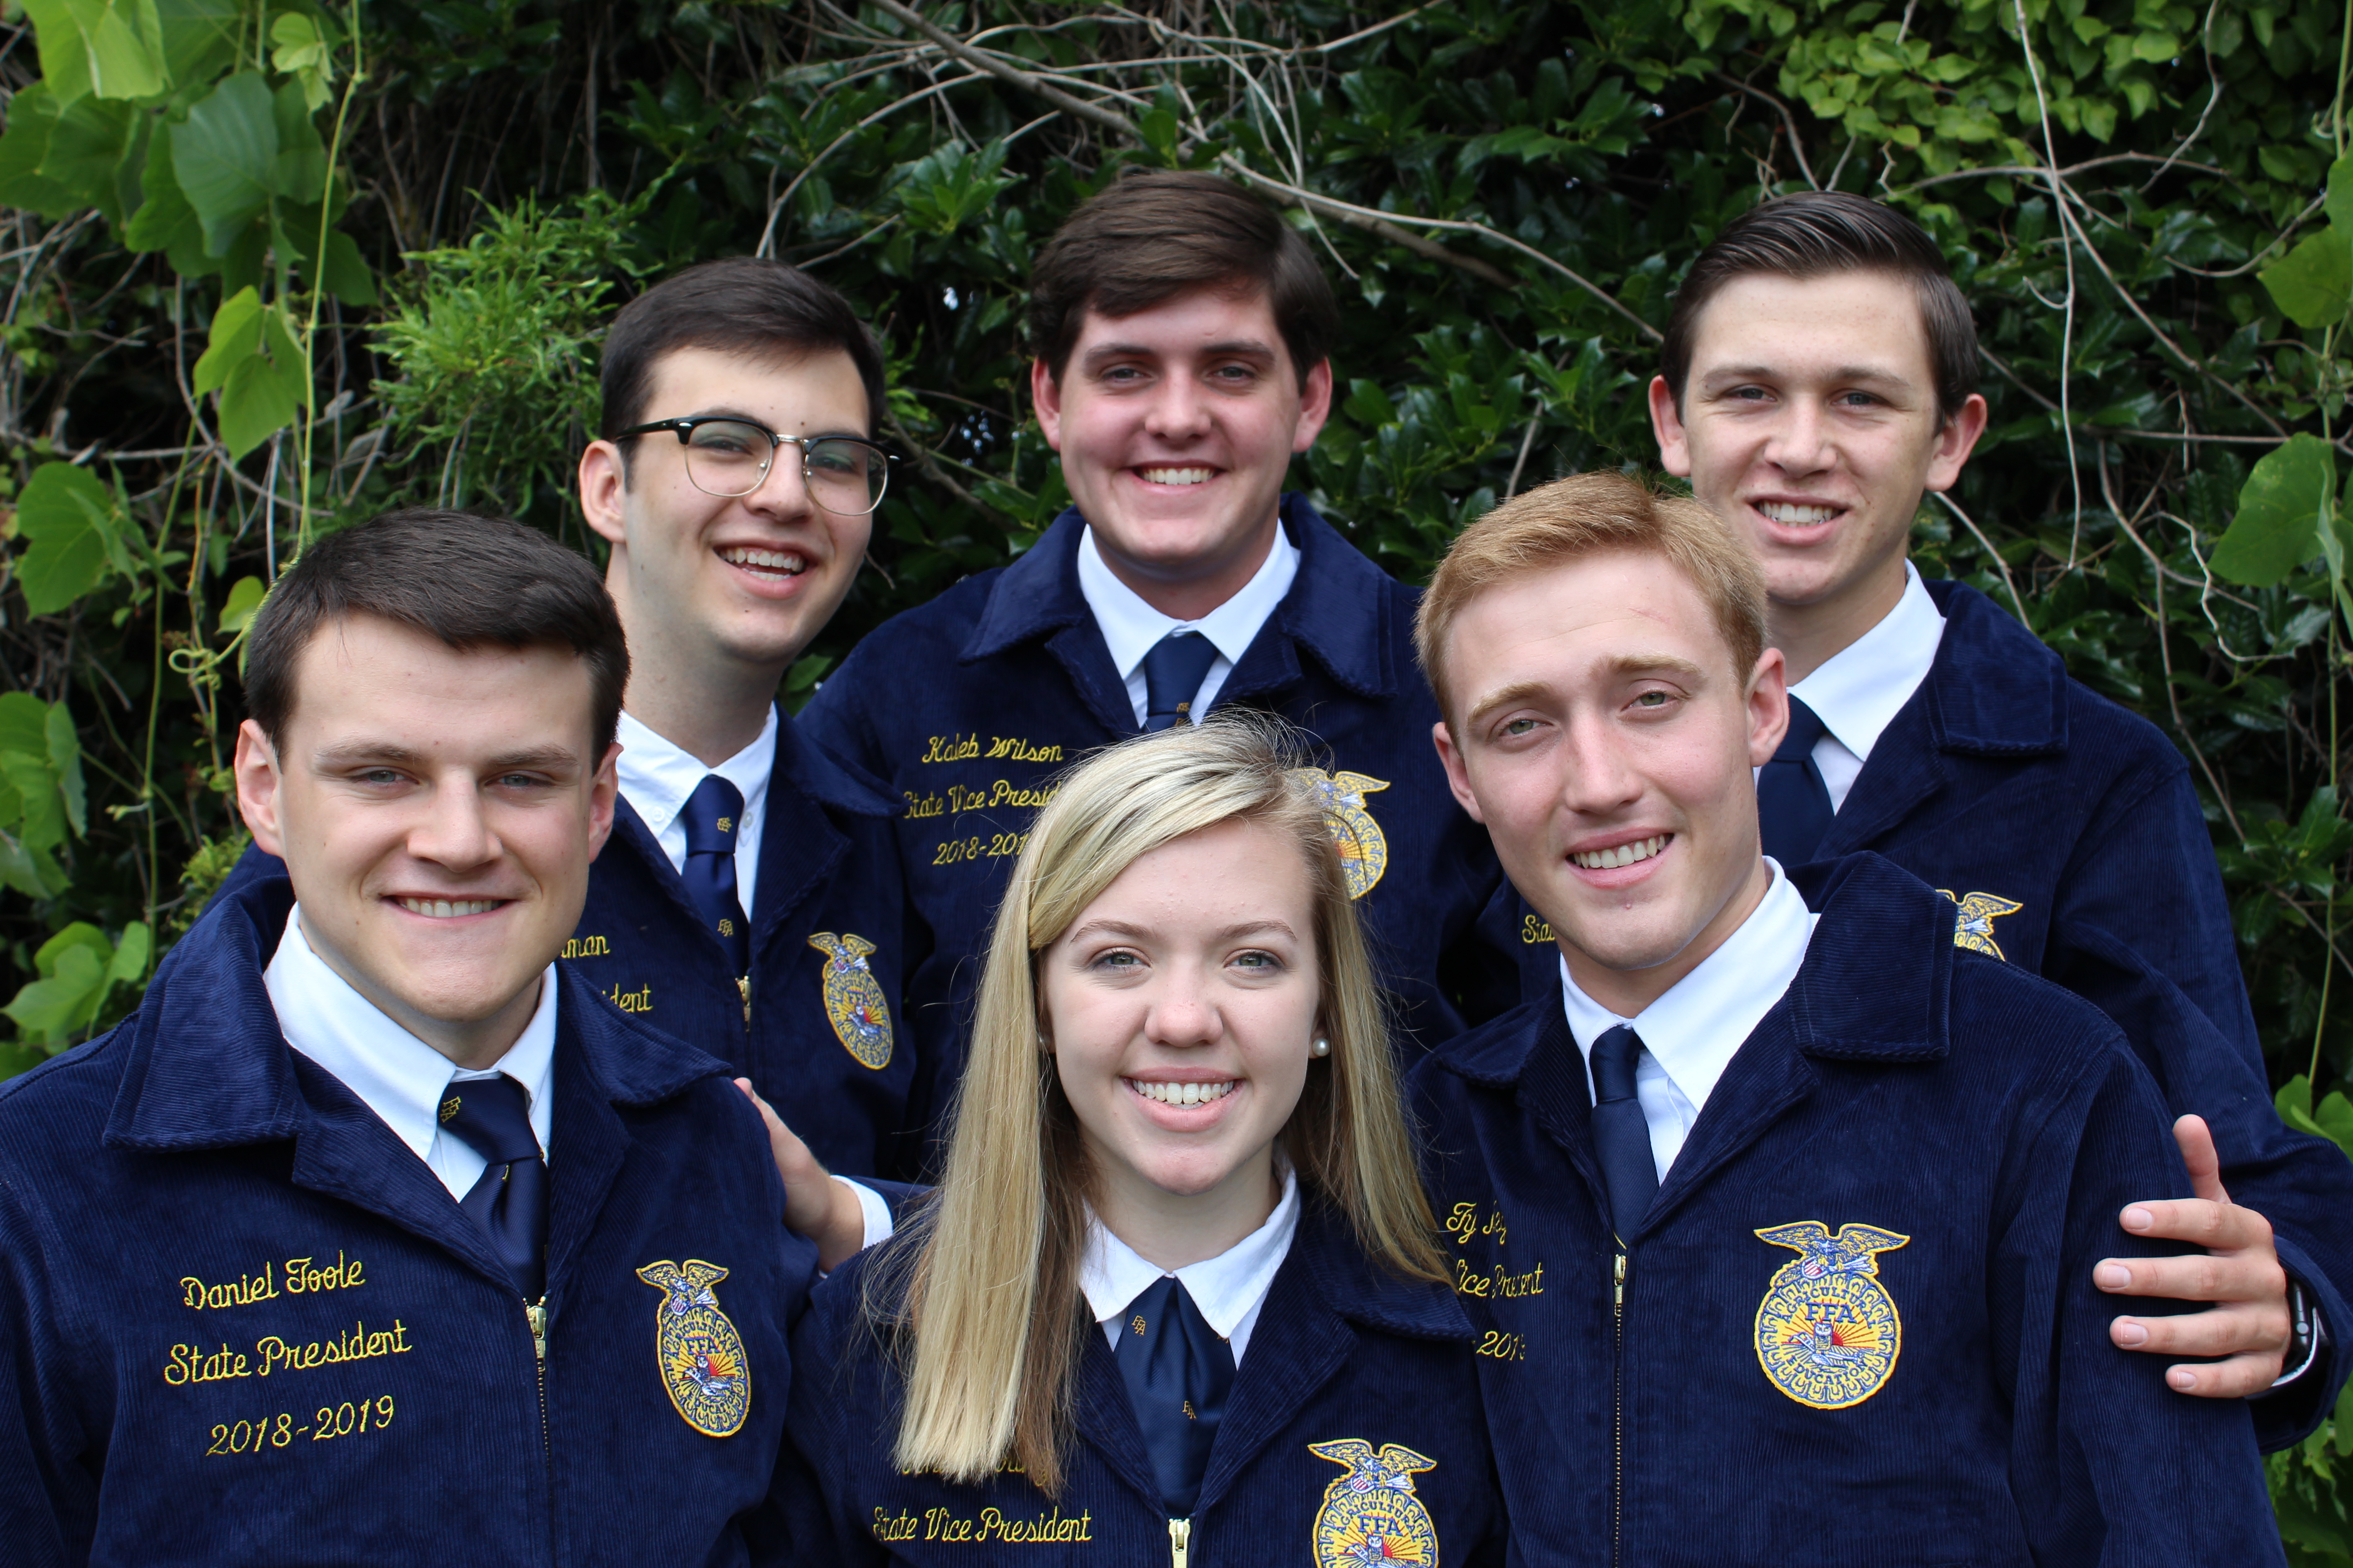

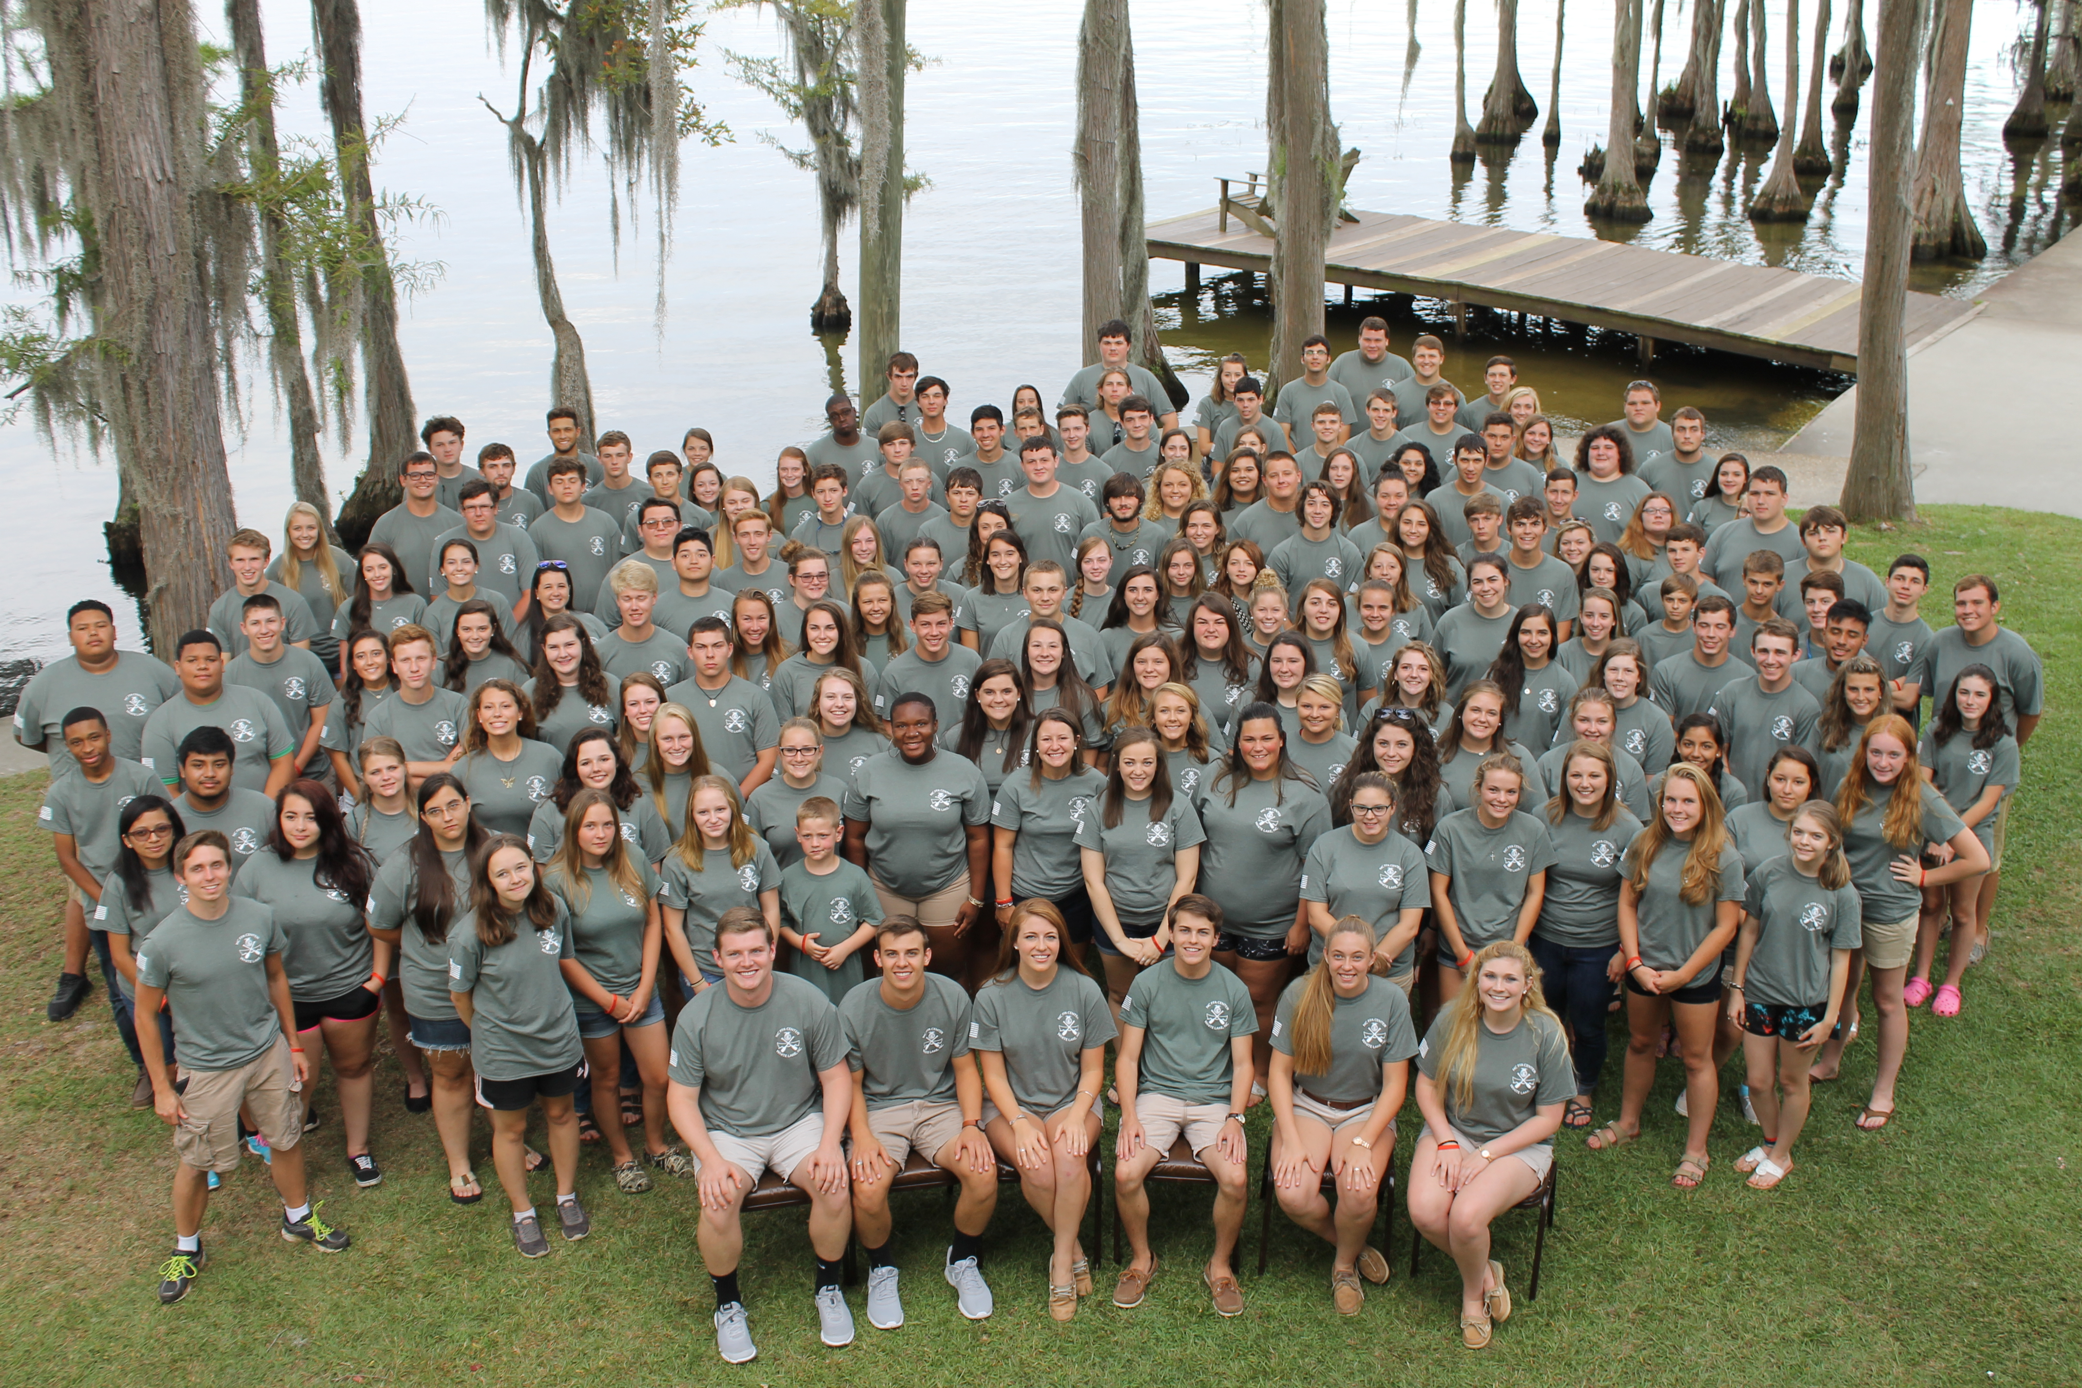

The FFA Mission
FFA makes a positive difference in the lives of students by developing their potential for premier leadership, personal growth and career success through agricultural education. The FFA motto is: Learning to Do; Doing to Learn; Earning to Live; Living to Serve

Membership
FFA membership has grown to 19,301 in 340 chapters across our state. FFA is a diverse organization, operating in rural, urban, and suburban schools. Students aged 12-21 enrolled in agricultural education programs are eligible for membership. Nationally, there are 653,359 members in 8,568 chapters.
Members can be found in all 50 states, Puerto Rico and the U.S. Virgin Islands.

Science, Business and Technology
The organization changed its name in 1988 from Future Farmers of America to the National FFA Organization to reflect its evolution in response to expanded agricultural opportunities encompassing science, business and technology in addition to production agriculture.

FFA members, who may enter the workforce directly from high school or pursue higher degrees through technical schools and four-year universities, are preparing for careers in agricultural market-ing, processing, communica-tions, education, horticulture, production, natural resources, forestry, agribusiness and other diverse agricultural fields.

Federally Chartered
FFA was organized nationally in 1928 in Kansas City, Missouri. In 1950, Congress granted FFA a federal charter, making it an integral, intracurricular part of part of public agricultural instruction under the National Vocational Education Acts. The North Carolina Association was chartered in 1929.

Structure
FFA operates on local, state and national levels. Student members belong to chapters organized at the local level. Agricultural education teachers serve as chapter advisors. Chapters are organized under the North Carolina FFA Association, headed by the State FFA Advisor and the State FFA Coordinator. The state association conducts programs, leadership conferences, career development events, provides recognition to students, conducts the state convention, and provides resources and support to agricultural teachers and FFA advisors. FFA is supported by several partner groups including the NC FFA Alumni, the NC FFA Foundation, NC Agriculture Teachers’ Association, as well as businesses and industries.

NC FFA Membership
- Today there are 19,301 FFA members, aged 12-21 in 340 chapters across North Carolina.
- 74% of FFA members are Caucasian, 14% are African-American and 12% are Asian, Native American or Hispanic.
- 91% of FFA members are in grades 9-12, 6% are in middle school, and 2% are high school graduates.
- 27% of FFA members live in rural farm areas, 40% live in rural nonfarm areas, 14% live in small towns, and 17% live in urban/suburban areas.
- FFA chapters are in some of the largest cities in NC including urban schools in Charlotte, Fayetteville, Raleigh and Greensboro.

Education
- More than 570 teachers deliver innovative and integrated curriculum to students in 319 programs
- In 2016-2017, there were more than 55,029 students taking agriculture classes in North Carolina.
- 92% of agricultural education programs offer agri-science, 71% offer biotechnology, 59% offer agricultural mechanics, 49% offer horticulture, 43% offer animal science and 24% offer environmental-science courses
- Top 4 courses taught in NC: Agriscience Applications, Animal Science I, Horticulture I, & Exploring Agriscience.
- 21 courses in agricultural education are taught in NC.
- 89% graduation rate for students enrolled in agricultural education.

Career Preparation
The agricultural education program provides a well-rounded, practical approach to learning through three components: classroom education in topics such as plant and animal sciences, forestry, biotech-nology, agri-marketing, etc.; hands-on supervised agricultural experience such as starting a business or working with a company; and FFA, which provides leadership opportunities and tests students’ agricultural skills.

Programs and Activities
Local, state and national FFA programs and activities help members develop public speaking skills, conduct and participate in meetings, manage financial matters, strengthen problem-solving abilities and assume civic responsibilities. Degrees earned at all levels recognize members’ increasing accomplishments.
Student Leadership
FFA is a student-led organization, meaning members elect their own officers and plan and conduct activities with supervision from their chapter advisors. A team of six state officers is elected each year, and plays a key role in planning the state convention and other events. They travel nearly 15,000 miles during their year of service advocating for agricultural education and representing the FFA association.

Headquarters
Since 1996, the North Carolina FFA Association has been headquartered at North Carolina State University within the College of Agricultural and Life Sciences and the Department of Agricultural and Extension Education.
North Carolina FFA Association
520 Brickhaven Drive, NCSU Campus Box 7654 Raleigh, NC 27695-7654
(P) 919-515-4206 (F) 919-513-3201
www.ncffa.org
NC FFA Center
Since 1928, the FFA Center at White Lake has provided students with outstanding leadership and recreational experiences. Summer programs include leadership and personal development conferences. During the center’s 90-year history, more than 131,000 students have had the experience of a lifetime. The NC FFA Center is one of the oldest FFA centers in the nation.
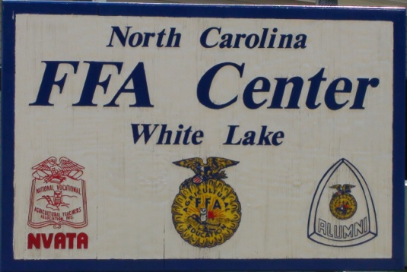

FFA Foundation
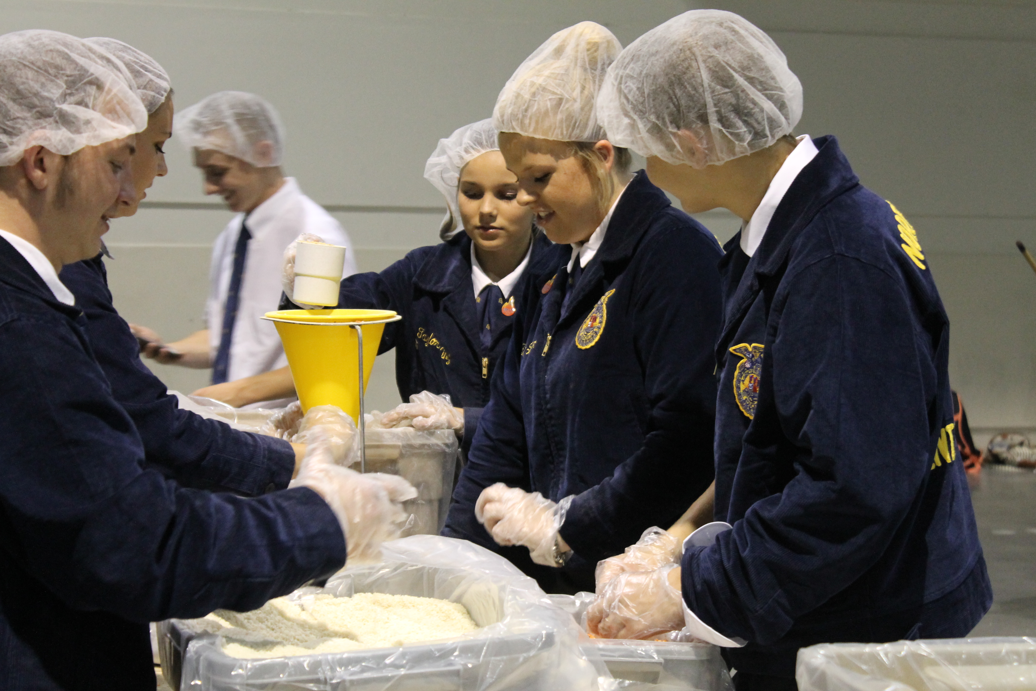
The North Carolina FFA Foundation works with business and industry, organizations, and individuals to recognize FFA achieve-ments and to support activities at the state, regional and local level. The foundation raises private resources for FFA activities and operates under the auspices of the North Carolina Agricultural Foundation, Inc., a non-profit, charitable and educational foundation.

FFA Alumni
Alumni members support state and local activities through numerous activities including a chapter grant program and the silent auction at state convention. Alumni membership is open to anyone who supports FFA. In North Carolina, more than 1,400 members in 54 affiliates support state and local programs.
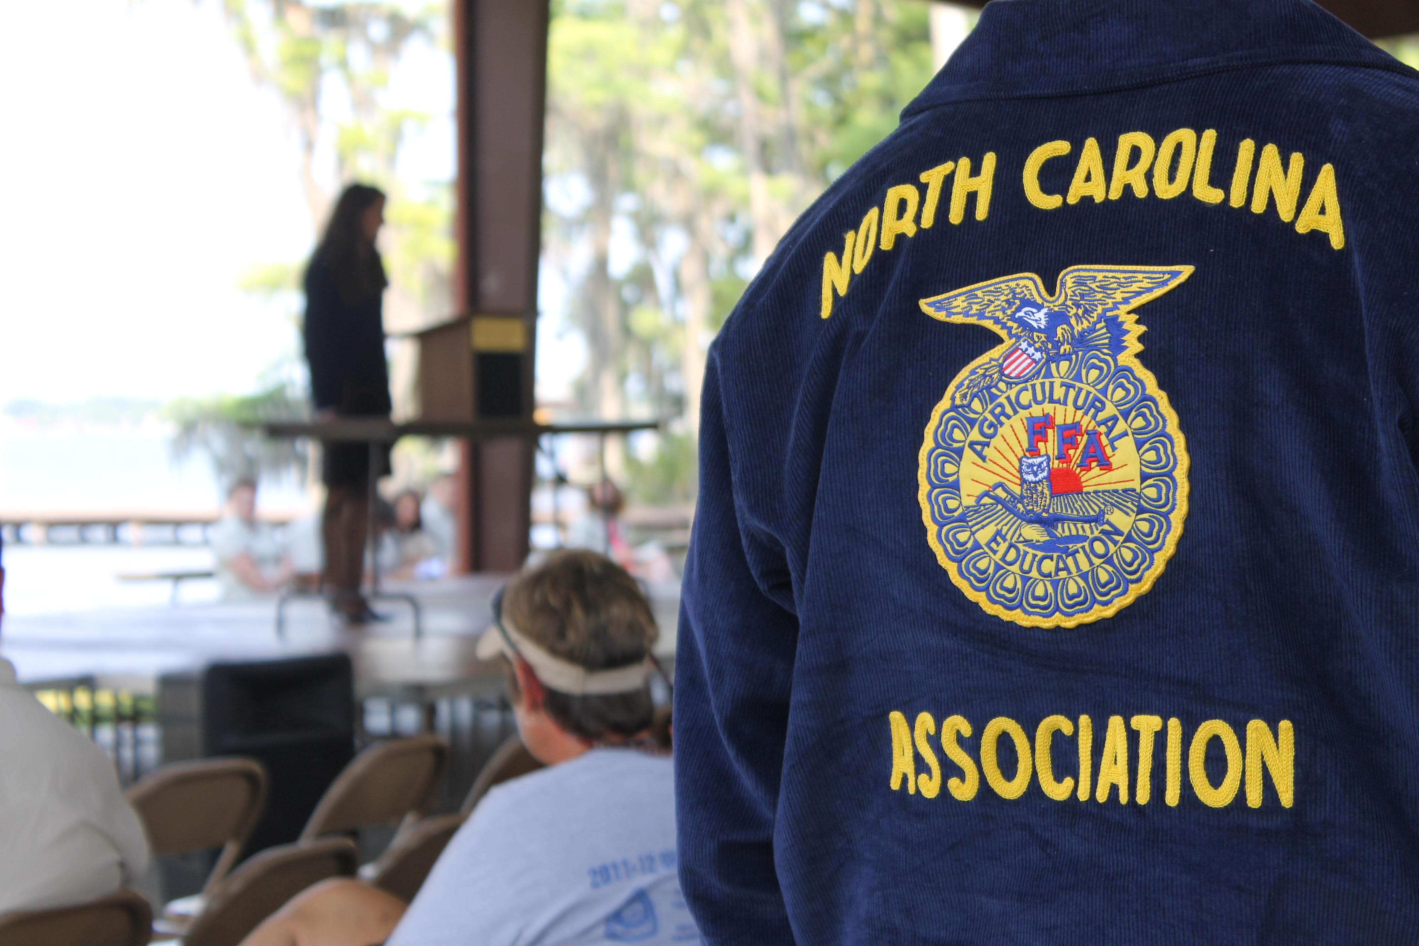

Learning To Do,
Doing to Learn,
Earning To Live,
Living to Serve

Career Exploration and Student Leadership
- Members participate in and learn advanced career skills in 47 national proficiency areas based on their hands-on work experiences in horticulture, mechanics, animal science, agriscience, and crop production areas. More than 270 students in North Carolina submitted proficiency applications last year.
- More than 2,800 FFA members participate in 43 career development events to be challenged by real-life hands-on tests of skill that prepare them for career success.
- Students are actively involved in leadership development as they attend regional and state workshops and conferences. Annually, more than 1,800 attend workshops presented by state and regional officers.

Industry Support
- Agriculture is the state’s largest employer with more than 20% of the workforce involved in some area of the industry. Agricultural Education prepares students for more than 300 careers in the science, business and technology of agriculture.
- In 2017, more than 750 sponsors provided nearly $1 million for local, regional, and state FFA activities and scholarships.

Updated 7/07/2018

