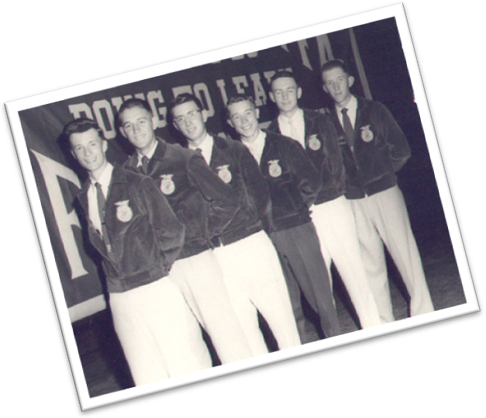
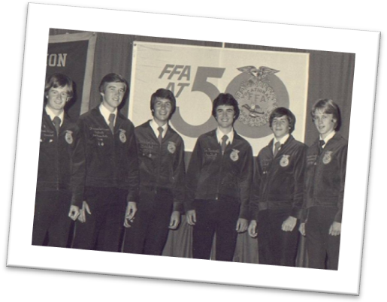
State FFA Officer
Selection
Process Handbook

North Carolina FFA Association

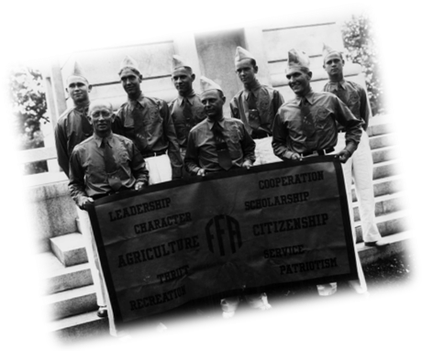
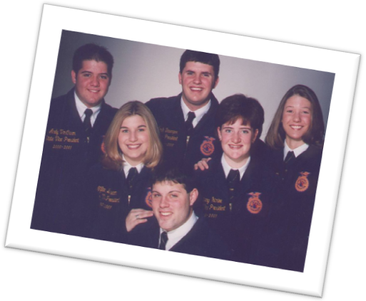

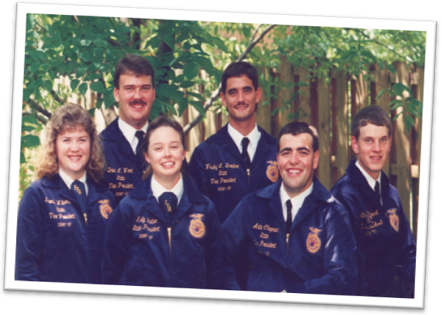
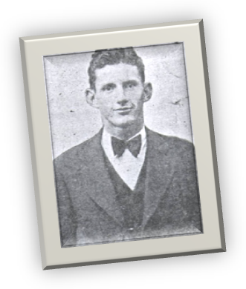

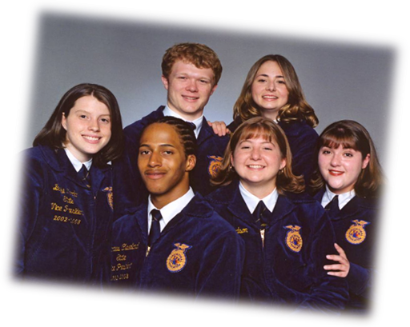
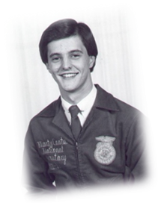
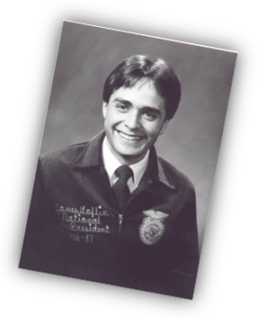

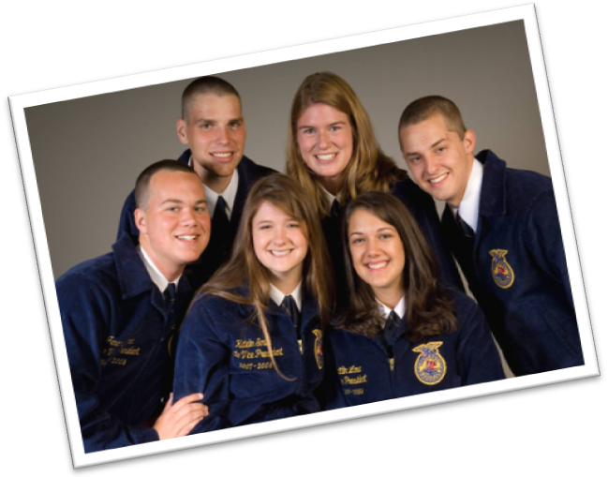
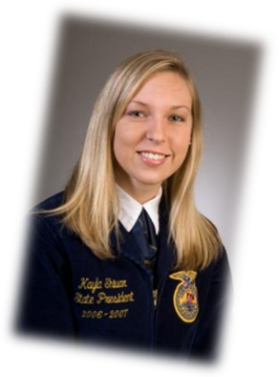

Introduction

Each year the North Carolina FFA Association selects six student members to represent the association as a state FFA officer. Throughout the year, this group has a variety of responsibilities. They are elected officials expected to represent the student membership during the board of director meetings. They are teachers of leadership and teamwork to regional FFA officers and chapter members. They are motivational speakers who will inspire members and non-members to heights they did not think they could achieve. They are communicators and public relations specialists on behalf of the North Carolina FFA Association building positive relationships across the state and across our nation. They are teammates to the other five state FFA officers and to the staff of the North Carolina FFA Association. They are learners, eager to absorb and grow to the fullest extent possible to fulfill their responsibilities. Selecting the six best candidates that will serve in this capacity is a challenging task for the twelve members of the nominating committee. To facilitate this committee’s success in accomplishing the goal a process exists – the state FFA officer selection process. This handbook details that process. All of the information is valuable and we encourage current candidates, advisors and prospective candidates to give this document careful consideration.

A Day in the Life of a State FFA Officer

Congratulations on your decision to run for a North Carolina FFA State Officer position, one that surely took hours of thoughtful consideration. Although you do not necessarily need a title or position to influence others, hopefully you will use your position on this team as a platform to reach and impact the people around you, including your family, friends, teachers and most certainly FFA members. Most people cannot say that they have nearly 17,000 people that look to them for guidance and leadership on a daily basis. However, as a state FFA officer, that is exactly what you have been asked to do. You are expected to be a positive role model everyday to the 17,000 members of the association by encouraging them to be their best. Doing so effectively will require a great deal of work and leadership on your part.
Though serving as an officer can be one of the most rewarding experiences that you can have, it does not all occur in the spotlight. There are many tasks that must be accomplished behind the scenes that you may not know about, but will allow your year to run much more smoothly. Those might include state officer meetings, planning workshops, work at the state office, practicing your skills, as well as a variety of other tasks.
When you are elected to state FFA office, your time becomes a precious commodity. Once you understand this and learn to manage your time effectively, your officer experience will be much more rewarding. You will have many things that require your time and full attention including, your school work and assignments, attending classes, participation in FFA activities and visits, other extracurricular activities, time with family and friends, and managing your free time. If you would rather live the life of a college student by following your own schedule, then state office may not be a good fit for you. Although your year of service can be exciting and rewarding, it will also be busy and stressful at times. You must utilize self-management and time management skills to accomplish all of your objectives.

Though you serve the members of North Carolina, first and foremost, you are a student. Remember, you are a leader and role model for other students and you can begin building that foundation by being an exceptional student. This requires you to maintain exceptional grades and continue a good standing with your academic institution. You should attend your classes regularly and complete assignments in a timely manner. You will also be asked to provide a class schedule to the State FFA Coordinator so that chapter visits may be planned appropriately.

State FFA Officers represent the epitome of what the association stands for and what we have to offer. Therefore, you are expected to uphold the highest ethics and morals and have a solid character foundation. This includes presenting yourself in a clean, professional manner, showing respect and compassion towards all people, following the FFA code of ethics, and remaining committed to the position, the association, the organization, and its members during your entire year of service. You will sign a contract between yourself and the association that will outline all of the expectations of the office and you are required to uphold that contract. The strong character of a state officer also implies that you will be willing to grow through your service. You should practice to become an exceptional public speaker and communicator, work to build positive relationships, and arrive at all events punctual and adequately prepared to represent the association. Though you might not know everyone that speaks or contacts you, students, teachers, community members and others will always identify you as a state officer. Therefore, wherever you are, wearing the blue jacket or not, you should always remember that you are still a representative of the FFA and your character should reflect that.

Even though you will be wearing the blue jacket many times this year, your effectiveness may very well be determined by what you do when you are not wearing the jacket. Remember, whether you are in a classroom studying chemistry or in classroom presenting a workshop, eating in a restaurant, attending a sporting event, or alone, FFA members are looking to you. A day in the life of a state officer is busy and exciting, but does require much of you. Consider these factors during your preparation to ensure that you can meet the full expectations of the position. If you can, we wish you the best in a most rewarding and exciting journey. We hope that you are up to the challenge – the FFA needs you!

State Officer Roles and Responsibilities
Job Summary
The State FFA Officer, under the direction of the North Carolina FFA State Advisor, is responsible for serving and representing nearly 17,000 FFA members. Officers represent the image and direction of the North Carolina FFA Association to teachers, state staff, teacher educators, agriculture industry executives, government leaders, the media and the general public.
The six state FFA officers will report directly to the State FFA Coordinator on the Agricultural Education State Staff at North Carolina State University. The officer is responsible for working as a team player with both agricultural education staff and five other team members in activities dedicated to advancing the mission of North Carolina Agricultural Education and the North Carolina FFA Association.
The position is an elected position provided for by the North Carolina FFA Association Constitution and Bylaws. If selected for the position, officers will hold the position for one year – from association convention to the following association convention. Throughout this time officers are responsible for a number of responsibilities.
A key role is that of being a communicator and spokesperson for FFA, agriculture and education. Officers prepare and deliver speeches and facilitated presentations for a wide variety of audiences including: students, parents, administrators, sponsors, teachers and teacher educators. Facilitated presentations and speeches will be made on a large group scale (i.e., 100 or more), in small groups (i.e., 20 or less), and one-on-one interviews (i.e. with media, or in conversation with various stakeholders). In addition to spoken presentations, officers will also author several written articles throughout the year.
Officers also play the role of relationship builder with partners in industry, education and government; as well as local and state stakeholders like parents, administrators, teachers and others. The individual is responsible for conducting visits, in cooperation with the North Carolina FFA Association and the North Carolina FFA Foundation, to share key messages regarding the organization, its mission, and success stories with partners in business and government.
Another key role is that of individual interaction with members. Officers meet with members one-on-one and serve as a mentor and role model. Officers also develop and deliver workshops for students on topics related to premier leadership, personal growth, and career success.
State officers also serve as student members of the North Carolina FFA Board of Directors. In this role they are responsible for representing the student voice in debating and establishing policy that contributes to the strategic goals of the organization.
Officers are also responsible for organizing and managing personal finances, correspondence, and most travel throughout the year. The officers work setting will normally be their personal home, college dorm, or the state FFA office. Officers will be provided with the technology and materials deemed necessary to carry out their responsibility effectively.

Essential Functions
- Participate in training, orientation, continual self-improvement and evaluation of activities as directed by the state staff, national staff, and past state officers.
- Serve as a member of the Board of Directors at all meetings as required by the state advisor and executive secretary.
- Attend and participate in the National Leadership Conference for State Officers and BLAST Off Training with the state officer team.
- Participate in making visits to business and industry as directed by the state staff.
- Represent the North Carolina FFA Association at other local, state and national activities as directed and scheduled by the state staff.
- Participate in planning and conducting the state’s leadership conferences.
- Plan and conduct chapter visits throughout the state and present workshops, meet local teachers and administrators, give speeches and perform other duties as necessary.
- Author and co-author journal entries and articles for print and online publications hosted by the North Carolina FFA Association and other partners.
- Participate and serve as an official delegate in the delegate process and attend the National FFA Convention.
- Attend chapter banquets and present keynote addresses as deemed necessary by the chapter advisor and state staff.
- Plan and conduct the state FFA convention with assistance from the State FFA Advisor and State FFA Coordinator.
- Plan, prepare, read, study, listen, review and practice to continue improving public speaking and teaching skills.
- Stay up to on agriculture, agribusiness and agricultural education facts and issues.
- Develop positive relationships with FFA members, advisors, staff, sponsors and the general public.
- Maintain a positive attitude and enjoy your year of service with members, advisors, and staff.

Additional Responsibilities
- Prepare and submit expense vouchers to the State FFA Coordinator receive reimbursements for FFA related expenses.
- Keep current with all correspondence. Examples of required correspondence include, but not limited to, thank you letters for business and industry visits and chapter visits, replies to member emails, correspondence with state staff, and other event planners at the local, regional, and state levels.
- Adhere to the State FFA Officer Contract at all times.
- Perform other duties as instructed by the State FFA Advisor and/or State FFA Coordinator.
Job Qualifications and Eligibility
Degree: Candidates must hold the State FFA Degree at the time of election
Membership: State Officers must be an active member during their year of service
Age: Candidates must have graduated from high school (Board action July 2009)
Competencies: The following is a listing of the essential competencies required for serving as a state FFA officer. The selection process is designed to screen candidates to find those who demonstrate these competencies consistently.
*Only candidates who are able to serve can participate in the selection process

Competency #1 – Communication
Demonstrates the effective use of various forms of communication, i.e., non-verbal, listening, written, speaking and facilitation to convey a message in both large group and one-on-one settings.

Competency #1 Builders:
  - Demonstrate non-verbal skills when communicating with others
  - Display listening skills when dialoging others
  - Demonstrate writing skills when communicating with others
  - Demonstrate speaking skills in a variety of settings (including board rooms, board rooms, auditorium, arena, small groups or one-on-one) and audiences (including business/industry, parents, schools officials, FFA members, elementary and secondary students)
  - Demonstrate facilitation skills in a workshop setting

Competency #2 – Team Player
Demonstrates the ability to work in a team setting, values diversity of opinion, and works to be inclusive in the process, and is willing to put others above self.

Competency #2 Builders:
2.1 Demonstrate the ability to work in a team pursuing a common goal
2.2 Demonstrate the acceptance of differing viewpoints during group or individual
Interactions
2.3 Demonstrate the ability to put team before self

Competency #3 – Areas of Knowledge
Demonstrates the ability to articulate the systemic nature of food, fiber, agricultural, and natural resources issues, FFA and educational issues.

Competency #3 Builders:
3.1 Demonstrate knowledge of the food, fiber, agricultural and natural resources industries
and their current issues
3.2 Demonstrate knowledge of FFA and its current issues
3.3 Demonstrate knowledge of America’s education system and its current issues.

Competency #4 – Organization
Demonstrates the ability to see the big picture, break large projects into smaller tasks, appropriately prioritize multiple demands, and use time management and organizational tools to produce quality results by identified deadline.

Competency #4 Builders:
4.1 Demonstrate effective time management
4.2 Demonstrate organizational skills
4.3 Demonstrate an ability to plan and prioritize

Competency #5 – Character
Displays a disposition that is genuine, responsible, honest, mature, confident, respectful and has a positive outlook on life.

Competency #5 Builders:
5.1 Displays reliability, integrity and trust among others
5.2 Displays adaptable and flexible characteristics
5.3 Displays a positive attitude
5.4 Displays sincerity and compassion toward others
5.5 Displays maturity
5.6 Displays coachable, life-long learning tendencies
5.7 Displays a strong work ethic

Competency #6 – Passion for Success
Displays personal attributes that are courageous and passionate in carrying out the FFA mission with contagious enthusiasm.

Competency #6 Builders:
6.1 Displays self-confidence
6.2 Committed to the FFA
6.3 Demonstrates an energetic disposition
6.4 Displays initiative in completing a task

Competency #7 – Influence
Demonstrates the ability to influence others through modeling expectations, build relationships, and growing the organization.

Competency #7 Builders:
7.1 Supports and motivates FFA members and partners
7.2 Mentors and coaches others
7.3 Committed to member representation

Competency #8 – Critical Thinking
Demonstrates the ability to seeks out solutions and resourcefulness in finding information.

Competency #7 Builders:
8.1 Demonstrates ability to solve problems
8.2 Demonstrates ability to think critically and conduct research

For more information on these competencies, look at the rubrics detailing how each competency builder will be evaluated throughout the selection process.
Officer Experience At-A-Glance
The following activities will consume the workload of the state officers’ year of service. Adequate time will be provided for training, preparation, evaluation, self-improvement, relationships, rejuvenation and team building.
State Officer Orientation June 1 day
BLAST Off Training June 3 days
National Leadership Conference for State Officers July 5 days
State Leadership Conference July/August 2 weeks
NC Agricultural Teachers’ Association Conference July 4 days
State Presidents Conference July 1 week
State Board of Directors Meeting July/February 3 days
Regional Officer Training August 3 days
Regional Leadership Conferences September 4 days
Delegate Training October 1 day
National FFA Convention October 1 week
International Experience January 10 days
FFA Week February 1 week
Chapter Visits August – May 3 weeks
Career Development Events November – April 10 days
Agribusiness Tour March 5 days
MEGA Conference March 1 week
State Officer Meetings and Additional Training July – June 3 weeks
Office Work August – June 2 hrs/week
Regional In-service Meetings March – April 3 days
Regional Rallies April – May 1 week
Chapter Banquets April – May 10 days
Convention Preparation June 3 weeks
State Convention June 1 week
Other Events July – June 1 week

Being an officer involves a commitment to things not listed here as well. For example, when officers are at home they are expected to stay “on-top-of-things” by checking and replying to e-mail; calling contacts; maintaining finances; and keeping up with correspondence. Being an officer means being available throughout the entire year and that includes some home office time as well as a large commitment to traveling for the association.

North Carolina FFA Association
State Officer Selection Process

Round I: One-on-One
- The interview will be six (6) minutes in length
- There will be three (3) unique questions asked by each committee member. The following competencies will be assessed and scored.
  - 1.5 - Facilitation skills in a workshop setting
  - 2.1 - Work in team in pursuing common goal
  - 2.2 - Acceptance of differing viewpoints
  - 2.3 - Team before self
  - 4.1 - Efficient time management
  - 4.2 - Organizational skills
  - 5.1 - Reliability/integrity/trust
  - 5.2 - Adaptable/flexible
  - 5.6 - Coachable/Lifelong learning
  - 5.7 - Work ethic
  - 6.2 - Commitment to FFA
  - 6.4 - Initiative
  - 7.1 - Supports and motivates FFA members and partners
  - 7.2 - Mentors and coaches others
  - 7.3 - Member representation
- Two (2) additional competencies will be scored by each committee member. Below are the possible competencies that will be assessed.
  - 1.1 - Non-verbal skills
  - 1.2 - Listening skills
  - 5.3 - Positive attitude
  - 5.4 - Sincerity/compassion
  - 5.5 - Maturity
  - 6.1 - Self-confident
  - 6.3 - Energetic
- A total of five (5) total data points or scores will be provided by each committee member for each candidate
- After the three questions are answered, the remainder of the time is provided for the nominating committee member to get to know the candidate individually

Round II: Round Robin
- The interview will be five (5) minutes in length
- This will be a scenario-based interview
- Each candidate will have a conversation with an adult member of the nominating committee regarding current agriculture, education, agricultural education or FFA issues
- The adult will play the role of a particular stakeholder
- All members of the nominating committee will observe and score each candidate
- Four (4) competencies will be scored by each committee member. Below are the possible competencies that will be assessed.
  - 1.2 - Listening skills
  - 1.4 - Speaking skills in a variety of settings
  - 2.2 - Acceptance of differing viewpoints
  - 3.1 - Agriculture Current Events and Issues
  - 3.2 - FFA Current Events and Issues
  - 3.3 - American Education and Agricultural Education Current Events and Issues
  - 5.3 - Positive Attitude
  - 5.5 - Maturity
  - 7.1 - Supports and motivates FFA members and supporters
  - 7.3 - Member representation
  - 8.1 - Ability to solve problems
  - 8.2 - Ability to think critically and conduct research
- A total of four (4) total data points or scores will be provided by each committee member for each candidate

Round III: Stand & Deliver
- The interview will be eight (8) minutes in length
- Each candidate will be given 30 minutes to prepare a speech
- This will be a scenario-based interview
- Each candidate will present a five-minute speech about a current topic in agriculture, education, agricultural education or FFA to the nominating committee
- Following the speech, the committee ask two (2) questions to each candidate
- The candidate will have three (3) minutes to respond to the questions
- Two (2) competencies will be scored based on the answers to the questions asked
  - 1.1 - Non-verbal skills
  - 1.4 - Speaking skills
  - 4.1 - Efficient Time Management
  - 4.2 - Organizational Skills
  - 4.3 - Planning and Prioritization
  - 6.1 - Self Confident
  - 7.1 - Supports and motivates FFA members and partners
  - 8.2 - Ability to think critically and conduct research
  - 3.1 - Agriculture Current Events and Issues
  - 3.2 - FFA Current Events and Issues
  - 3.3 - American Education and Agricultural Education
- Three (3) additional competencies will be scored by each committee member
- A total of five (5) total data points or scores will be provided by each committee member for each candidate

Round IV: Facilitation
- The interview will be eight (8) minutes in length
- Each candidate will be given 30 minutes to prepare an eight-minute portion of a workshop
- This will be a scenario-based interview
- Each candidate will present the portion of the workshop to the FFA Members on the committee
- FFA Members on the committee will interact with the candidate as they present their workshop
- All committee members will score each candidate. Below are the competencies that will be assessed.
  - 1.1 - Non-verbal skills
  - 1.2 - Listening skills
  - 1.4 - Speaking skills
  - 1.5 - Facilitation skills
  - 4.1 - Time management skills
  - 4.2 - Organization skills
  - 4.3 - Ability to plan and prioritize
  - 5.2 - Adaptable/ flexible
  - 5.7 - Work ethic
  - 6.3 - Energetic
  - 8.1 - Ability to solve problems
  - 7.1 - Supports and motivates FFA members and partners
  - 7.2 - Mentors and coaches others
- A total of four (4) total data points or scores will be provided by each committee member for each candidate

Round V: Personal Round
- This interview will be five (5) minutes in length
- Each candidate will be asked the same four questions by members of the committee
- Each candidate will provide their answers to all 12 committee members
- Two (2) competencies will be scored based on the answers to the questions asked
  - 2.1 - Ability to work in team pursuing common goal
  - 2.3 - Ability to put team before self
  - 5.1 - Reliability/integrity/trust
  - 5.3 - Positive attitude
  - 5.4 - Sincerity and Compassion
  - 5.5 - Maturity
  - 5.6 - Coachable/Lifelong learning
  - 6.1 - Self-Confident
  - 6.2 - Commitment to FFA
  - 6.3 - Energetic
  - 6.4 - Initiative
- Three (3) additional competencies will be scored by each committee member
- A total of five (5) total data points or scores will be provided by each committee member for each candidate

Application
- The application will be evaluated and scored by adults independent from the nominating committee
- Four (4) different competencies will be scored
  - 1.3 - Writing skills when communicating with others
  - 4.2 - Organizational skills
  - 4.3 - Ability to plan and prioritize
  - 5.1 - Reliability/Integrity/Trust
  - 5.4 - Sincerity/compassion
  - 5.6 - Coachable/Life-long learning
  - 5.7 - Demonstrates work ethic
  - 6.2 - Commitment to FFA
  - 6.4 - Initiative
- A total of 32 data points will be assigned as scores for the application

Written Test
- The test will be one (1) hour in length
- Thirty (30) multiple choice questions on agriculture, FFA and education. The competencies assessed are below.
  - 3.1 - Knowledge of agricultural industry and current issues
  - 3.2 - Knowledge of FFA and current issues
  - 3.3 - Knowledge of America’s education system/Ag Ed/Issues
- Each question counts as one data point or score

Writing Exercise
- This exercise will be thirty (30) minutes in length
- This is a scenario-based activity
- Will be evaluated and scored by adults independent from the nominating committee
- Five (5) different competencies will be evaluated and scored
  - 1.3 - Writing skills when communicating with others
  - 8.1 - Solve problems
  - 8.2 - Think critically and conduct research
- A total of ten (10) data points will be assigned as scores for the writing exercise

State Officer Selection Process
Sample Schedule

Day 1

9:00 am – 12:00 noon Nominating Committee Training
10:00 am – 10:45 am Candidate Check-in
11:00 am – 12:00 noon Written Test
12:00 noon – 1:30 pm Lunch
1:30 pm – 4:30 pm Round I: One-on-One Interviews
4:45 pm – 7:15 pm Round II: Agricultural Issues
5:00 pm – 5:30 pm Writing Exercise – Group 1
6:30 pm – 7:00 pm Writing Exercise – Group 2
7:30 pm – 9:00 pm Dinner
9:30 pm – 10:00 pm Nominating Committee Meeting

Day 2

7:00 am – 7:45 am Floating Continental Breakfast
7:45 am – 8:15 am Nominating Committee Meeting
7:45 am – 12:30 pm Round III: Stand & Deliver
12:30 pm – 1:30 pm Lunch
1:45 pm – 6:15 pm Round IV: Facilitation Round
7:00 pm – 9:00 pm Dinner
9:30 pm – 10:00 pm Nominating Committee Meeting

Day 3

7:00 am – 7:45 am Floating Continental Breakfast
8:00 am – 11:00 am Round V: Personal Round
Candidates may depart once their interview is complete
11:00 am – 12:00 noon Nominating Committee Meeting
12:00 noon – 1:00 pm Lunch for Nominating Committee only
1:00 pm – until Nominating Committee Deliberations

*Note: This schedule is subject to change

